GET STARTED WITH TABLEAU

[DATA VISUALIZATIONS WITH TABLEAU](https://www.coursera.org/learn/visualize-data/lecture/sLxV4/data-visualizations-with-tableau)

We've already discussed how helpful data visualizations can be when we want to fit a lot of knowledge into a small space.

Now it's time to explore a powerful tool that can help you create these visualizations and bring your data to life. It's called Tableau, a visual analytics platform that makes it a lot easier to explore and manage data.

You might remember hearing a bit about Tableau in some of our earlier discussions, but you're about to discover even more. Plus, when you get comfortable with Tableau, you'll find it even easier to use similar tools, giving you another skill that will help you stand out in the job hunt.

Coming up, we'll cover some of the features that make Tableau effective for visualizations and why it's used across industries. After that, the fun really starts.

We'll jump right in and explore the Tableau interface, identifying and applying the various tools it has to offer. I'll show you how to add data sources, control visual elements, and work with a variety of features that will make your visualization really powerful.

Like any software platform, there's some best practices to keep in mind. So I'll show you some examples of the good and the bad when it comes to visualizations.

We'll also get creative using color vision deficiency palettes to make our visualizations more accessible, and we'll show you how multiple data sources can be combined to tell a more comprehensive story. By the time we wrap up here, you'll be able to publish your own visualizations on Tableau.

I am so excited to lead you on this Tableau tour. It's another useful tool that you'll be able to turn to as a future data analyst so that you can visualize and publish data you care about. After all, data has a story, and this is your chance to share it with others. All right, let's discover what it's all about.

[TABLEAU PUBLIC AND OTHER ONLINE TOOLS](https://www.coursera.org/learn/visualize-data/lecture/HD29b/tableau-public-and-other-online-tools)

Welcome back. Mastering online tools like Tableau will make it easier for your audience to understand difficult concepts or identify new patterns in your data. Need to help a news outlet showcase changing real estate prices in regional markets? Check.

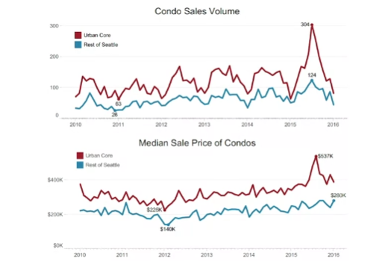

Want to help a nonprofit use their data in better ways to streamline operations? Check.

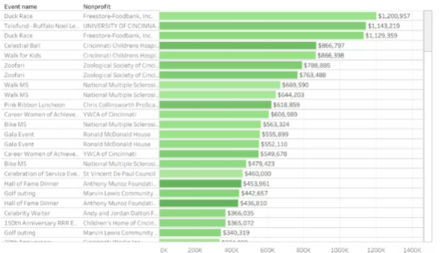

Need to explore what video games sales look like over the past few decades? Double check.

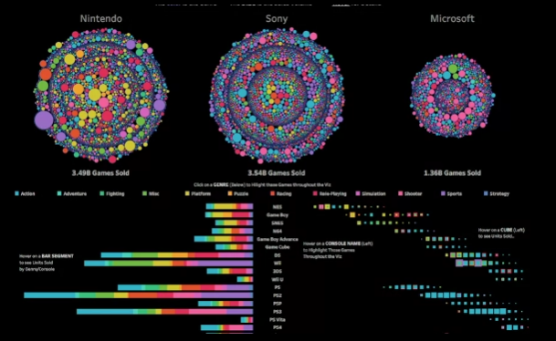

Many different kinds of companies are using Tableau right now to do all of these things and more.

This means there's a good chance you'll end up using it at some point. in your career. But I'm getting ahead of myself.

First, let's talk about what Tableau actually is.



But it's not all business all the time. Take this data viz, for example, created by Tableau enthusiast Steve Thomas to record Bigfoot sightings across the US.

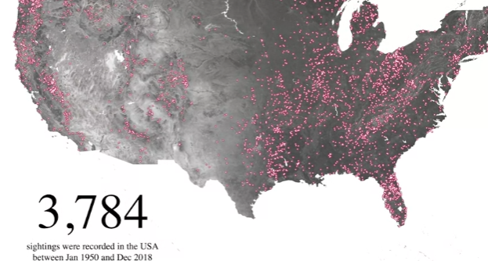

It's available on Tableau Public, which we will be using together in our activities in this course.

Tableau can help you make and easily share interactive dashboards, maps, and graphs with your data. Without any coding, you can connect to data and lots of formats like Excel, CSV, and Google Sheets. You might also find yourself working with a company that uses another option, like Looker or Google Data Studio. for example. Like Tableau, Looker and Google Data Studio help you take raw data and bring it to life visually, but each does this in different ways.

[BEGIN TO USE TABLEAU PUBLIC](https://www.coursera.org/learn/visualize-data/supplement/HyqLQ/begin-to-use-tableau-public)

As you’ve been learning, Tableau is a powerful data visualization tool used by data professionals around the world. Tableau offers a free browser version of its software, Tableau Public, which enables learners like you to try out its capabilities. Tableau Public is the software you will use throughout this course on data visualization. In this reading, you will sign up (if you haven’t already done so) and log in to Tableau Public. Then, you’ll be guided through the Tableau Public platform and account features.

## **Sign in to Tableau Public**

### **Sign in with an existing account**

If you already have a Tableau.com account, use your existing login credentials to sign in to Tableau Public. Click [here](https://community.tableau.com/s/tableau-public-faq#subhead6) to learn more. If this is your first time signing in to Tableau Public with your Tableau.com account, set an account password by resetting your password. To do so, select [reset password](https://id.tableau.com/resetPassword).

### **Sign in for the first time**

If you do not yet have a pre-existing Tableau.com or Tableau Public account, use these instructions to create one. If you have a Tableau Public account, skip ahead to the “Navigate Tableau Public” section

First, go to the [Tableau Public home page](https://public.tableau.com/). If this link does not open to the Tableau Public homepage, enter public.tableau.com in your browser’s address bar.

**Note:** Tableau Public works best on Chrome (Windows, Mac, Android), Edge (Windows), Firefox (Windows and Mac), Safari (Mac and IOS).

Next, click **Sign Up for Tableau Public**.

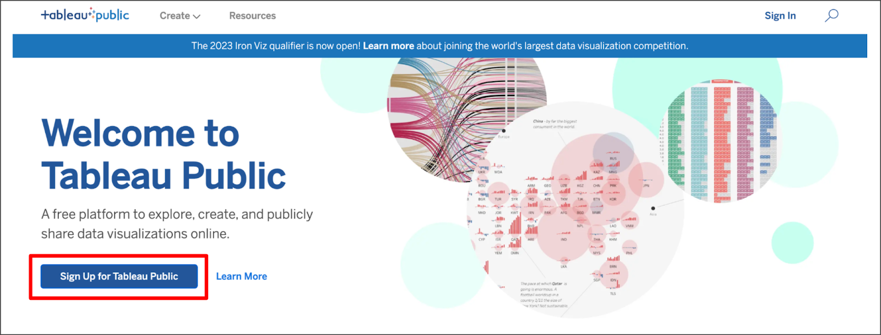

This is a free platform to explore, create, and publicly share data visualizations online. There is a hyperlink option to learn more.

Fill in all the required fields and click **Create My Account**.

## **Navigate Tableau Public**

The Tableau Public home page contains resources and guides to help data professionals learn more about and get inspired by data visualizations. You can explore any and all of the links on this landing page to help enhance your knowledge of Tableau. If you’re new to Tableau Public, the most helpful place to start is the Learn page, which has how-to videos, (free to use) sample data, and user forums.

### **Access My Profile**

During this course, the instructor will give you the opportunity to log in to Tableau Public and follow along in the creation of a data visualization. Select the user symbol icon on the Tableau Public homepage then **My Profile** from the dropdown menu to get started.

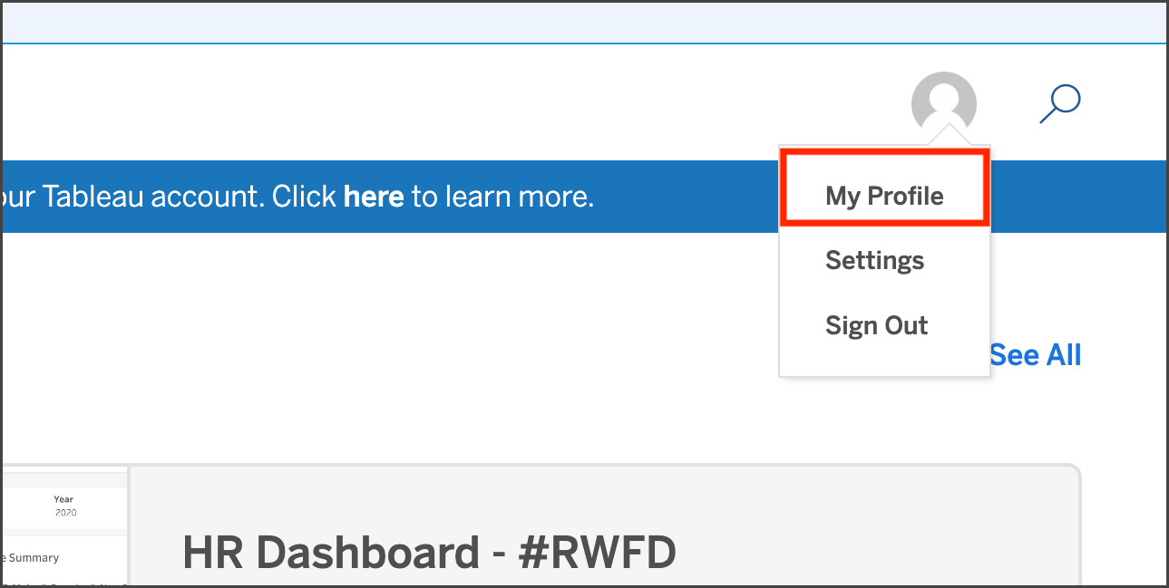

## **Create a Viz**

Within your Tableau Public profile, you’ll find tabs for **Vizzes**, **Favorites**, **Following**, and **Followers**. If you haven’t created a public viz yet, there are two buttons in the **Vizzes** tab: **Create a Viz** and **Explore Sample Data**. Selecting the Explore Sample Data button is a great way to try out the tool on your own and test how the software works in a sandbox-like environment. There is also a **Create a Viz** button at the upper right of the page. At the instructor’s prompt, select either of the two **Create a Viz** buttons.

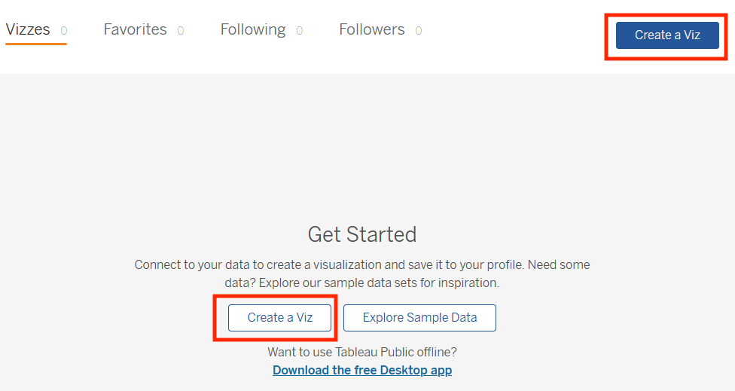

The text on this page reads: Connect to your data to create a visualization and save it to your profile. Need some data? Explore our sample data sets for inspiration. Want to use Tableau Public offline? There is a hyperlink to Download the free Desktop app.

After you select **Create a Viz**, you will be directed to a screen that asks you to connect to data. Tableau Public needs data to work with, such as a spreadsheet, .json, or .csv file, for example. When prompted by the instructor, upload the data provided using the **Connect to Data** screen. You can also use any of the sample data that you find in the [Learn](https://public.tableau.com/app/learn/sample-data) area.

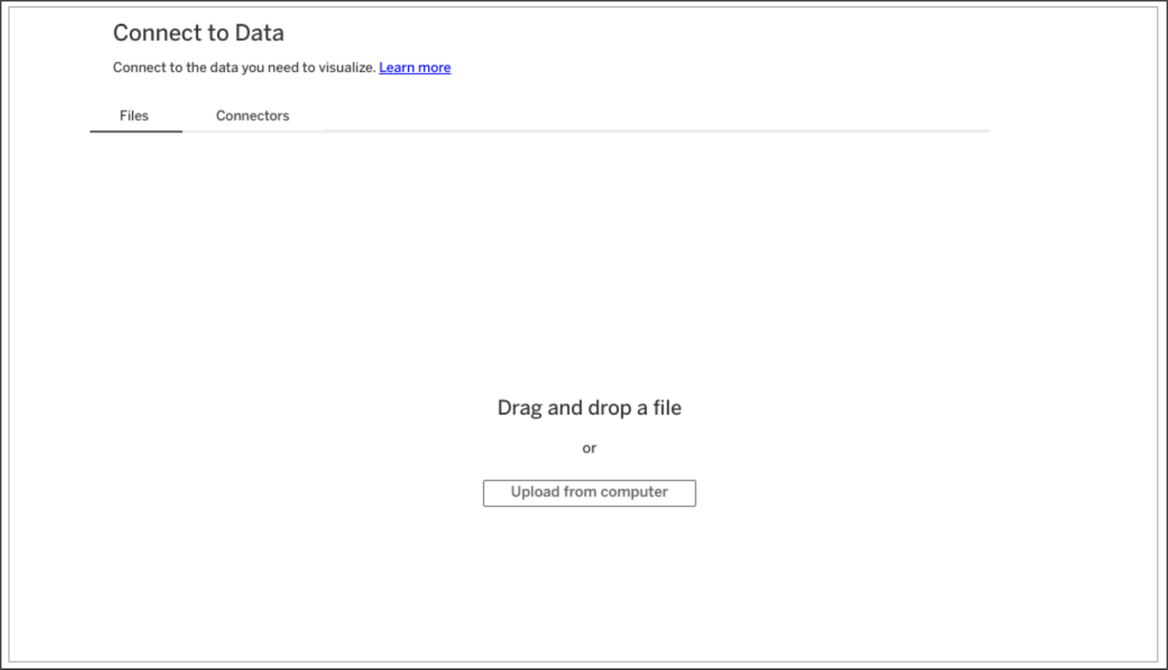

The Connect to Data screen. Connect to the data you need to visualize. There is a hyperlink to Learn more. The Files tab is open, where you can drag and drop a file or upload from the computer.

After you upload data, you are ready to start designing data visualizations. Happy designing, future Viz Whiz!

## **Key takeaways**

Now that you’ve completed this reading, you should be able to access Tableau Public with your own account, navigate the Tableau Public resources, and connect to data. These are your first steps to learning how to design data visualizations with Tableau!

## **Resources for more information**

To help you troubleshoot or to learn more, explore the following links:

* Tableau Public not working? Check out these [Technical specifications and storage requirements](https://www.tableau.com/products/techspecs#public).
* [The Tableau Public Discover page](https://public.tableau.com/app/discover) includes ‘Viz of the Day’ and other beautiful vizzes designed on the platform.
* [Google Career Certificates](https://public.tableau.com/profile/grow.with.google#!/) page on Tableau Public: This gallery contains all the visualizations created in the video lessons so you can explore these examples more in-depth.
* [Tableau Public resources page](https://public.tableau.com/app/learn/community-resources): This links to the resources page, including some how-to videos and sample data.
* [Tableau Accessibility FAQ](https://community.tableau.com/s/question/0D54T00000C6nsjSAB/faq-accessibility?_ga=2.189822891.1471813031.1653667812-1362170659.1601475625): Access resources about accessibility in Tableau visualizations using the FAQ, which includes links to blog posts, community forums, and tips for new users.
* [Tableau community forum](https://community.tableau.com/s/): Search for answers and connect with other users in the community on the forum page.
* [Build Your Data Literacy course](https://trailhead.salesforce.com/en/content/learn/trails/build-your-data-literacy): Build your data literacy skills in order to interpret, explore, and communicate effectively with data.

[MEET TABLEAU](https://www.coursera.org/learn/visualize-data/lecture/YbP1d/meet-tableau)

Hello, and welcome to the intersection of analytics and art, the place where data analysts like me go to unleash the true potential of data with meaningful visuals, and the place where future data analysts like you can also go to learn how to do this.

Welcome to Tableau, one of the many visualization platforms that helps you do more with your data. When you turn data into a visualization, you get to watch it transform before your eyes into a meaningful story that people can connect to and care about. Visualizations in Tableau are dynamic, not static. As a quick refresher, dynamic visualizations are interactive or change with time. The interactive nature of these graphics means your audience has some control over what they see, and you have incredible flexibility with how you create them. So let's create our own visualization using a preloaded table on Tableau Public. It's important to note that there's different ways to create visualizations in Tableau. Tableau has a few different offerings, but for this course we're using Tableau Public in browser, which is free.

One cool thing about Tableau Public is the public gallery with data viz examples from across the web. For now, you'll be working with one of these examples from the gallery. You'll be copying over data workbooks to your own profile to start creating and publishing visualizations.

To get started, sign into your Tableau Public account. You can check out an earlier reading for more details. Then, to access the Workbook, open the Google Career Certificates page on Tableau Public by clicking this link [Google Career Certificate Tableau](https://public.tableau.com/profile/grow.with.google#!/). This opens a new tab that is still linked to your account.

There are a few workbooks loaded up with different data sets that you can save to your own profile. These are a great starting point for creating your own visualizations. There will also be a resource following this video that goes through how to download Tableau and load your own data. But for now, let's use this gallery as a starting point. Now click to view the workbook titled, **Just the Data- World Happiness**.

This brings up the data table we use to help create the World Happiness data viz that's in the gallery. Next, go to the menu in the upper right corner and click Make a copy.

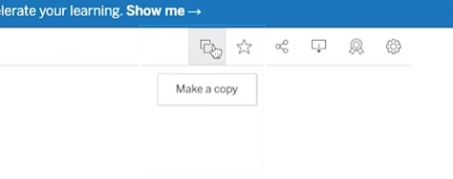

At this point, Tableau will save a copy of this workbook to your own profile, so you can create your own visualizations.

Now that you're working in your own copy, create a new worksheet so you can build a data viz from scratch. You'll click on Worksheet in the top menu, and then New Worksheet.

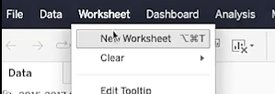

To start building your data viz, add Country as a detail in the marks shelf. You can do this by dragging the Country table over to the Detail icon.

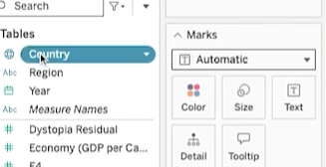

This sets up your viz as a world map to represent the data in the table.

Next, add the Happiness Score to the color on the mark shelf.

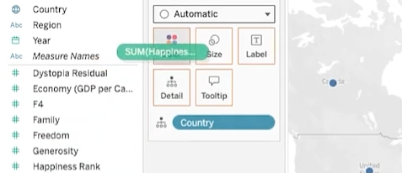

This applies a color scheme to the viz, in this case, shades of blue. This range of colors doesn't offer a lot of contrast, especially for people with color vision deficiencies.

So to adjust the colors, click the Color menu and click Edit Colors.

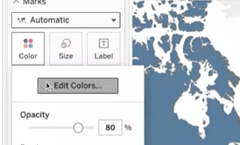

Then change the color scheme to Green-Blue Diverging and **check the box for stepped colors**, which shows a clearer difference between the highest and lowest happiness score.

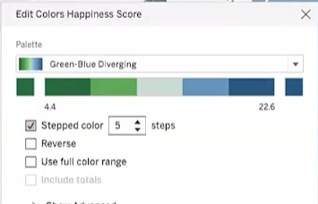

Darker blue means a higher happiness score, whereas darker green relates to a lower happiness score. You can see this broken down in the scale, so with just a couple of steps we have an interesting visualization that shows happiness data in a way that's easy to digest.

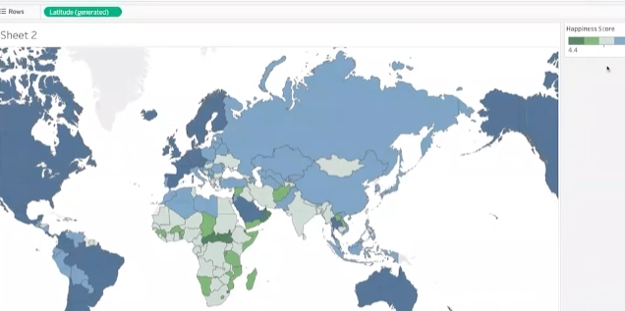

The countries and colors on the map are readable and offer some great insights. But let's keep going so we can explore more Tableau features to refine your data viz.

Because there are three years of data in the table we're using, you can **filter the data** to only include 2016. Using multiple years can also be useful depending on your objective. Regardless, you have lots of options for filtering. So we'll add Year to the filter shelf.

Then we'll choose to filter by year. And we'll select 2016. Let's focus our visualization on one region, the European region. To do this, move your cursor to find the view toolbar.

Use the tools in this toolbar to pan to and zoom in on the European region.

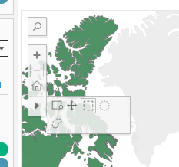

This takes some time and practice. Once you have a pretty good view of Europe and its surrounding areas, use the shape tools in the same toolbar to select as much of Europe as you can. Since we're practicing, make your best guess if you're not sure which countries to include. If you were working on a visualization that you were going to share with others, you'd want to double check that it was accurate.

Hover your cursor over one of the countries and it shows you data about that specific country, as well as all the countries you've selected in the region.

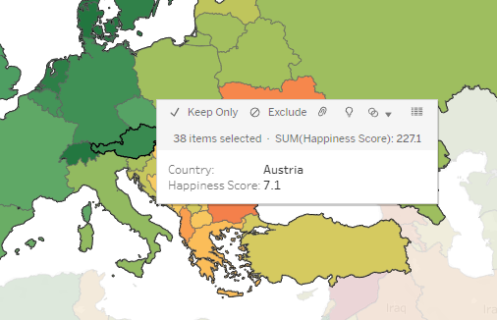

Then, use the Lasso selection tool to select just a few countries like this.

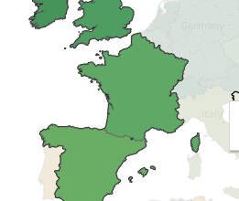

Keep Only, this applies another filter, this time to the country you're including in your viz.

You'll notice that the color scheme of these countries is updated. This reflects that the range of colors is now only being applied to these countries. Countries in this region might have been in the same part of the range when compared to the rest of the world, but now they're in different parts because the data being measured is specific to this region.

To make your viz even better, add the Happiness Score as a label in the map.

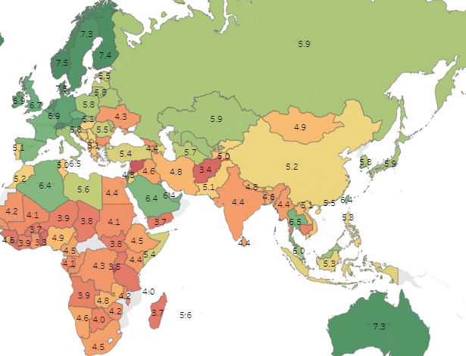

You can now see a happiness score for each country on the map. This adds an extra layer of detail to the viz, to help make a connection to the actual data. There's an option to change the data type of the happiness scores from decimals to whole numbers. But when you do this, you lose the contrast that the values with the decimals offer. So change it back to show the happiness score as a decimal.

Now, to make it even more interactive, let's add a filter with a slider. This will allow your audience to filter by happiness score, so they can focus on fewer countries. But first, let's bring in more of the map we started with. To do this, hover on the map, and select the zoom home icon in the toolbar to reveal more countries on the map.

Next we're going to add Happiness Score to the filter shelf. We'll select All Values and click Next.

Then for the range of values, we'll click OK, to accept the default settings. In the filter shelf, click the drop down to open the menu for the Happiness Score and select Show Filter.

If we select the drop down for the menu again, we can confirm that Show Filter has a checkmark next to it. You can toggle the checkmark to display or not display the filter.

When the show filter is marked, a slider is displayed to the right of the map. Now try filtering to show a happiness score of 6.0 or below.

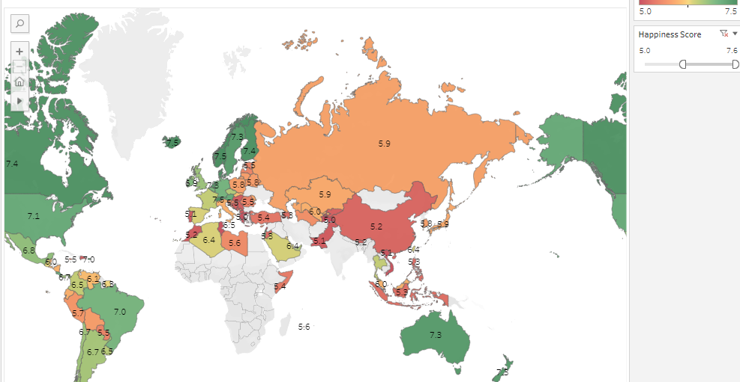

And there you have it, our first visualization based on data we brought in from an external source. Pretty powerful, right?

We'll save(publish) our viz so we can admire it anytime we want to, and maybe even practice using the Tableau tools with it. It's always important to save your work, but make sure not to include any personal information in your file name.

All of the data visualizations created in Tableau Public are visible to, well, the public.

You can also keep your visualizations hidden, you'll see the eye with a slash through it on your viz, and the viz will remain hidden. It's up to you, but lots of data viz created by users like you, are viewable. In fact, you can easily check them out by searching on Tableau Public.

Then you can search for any kind of data viz, including World Happiness visualizations. You'll come across all types of data viz, many with advanced settings.

Some of the examples you'll find in the gallery are stronger than others.

Coming up, we'll talk about effective data visualizations and some ways you can make your data viz work even stronger. See you soon.

[VISUALIZATIONS IN SPREADSHEETS AND TABLEAU](https://www.coursera.org/learn/visualize-data/supplement/bDdpK/visualizations-in-spreadsheets-and-tableau)

This reading summarizes the **seven primary chart types**:

**1- Column**

**2- Line**

**3- Pie**

**4- Horizontal bar**

**5- Area**

**6- Scatter**

**7- Combo**

Then, it describes how visualizations in spreadsheets compare to those in Tableau.

## **Primary chart types in spreadsheets**

In spreadsheets, **charts** are graphical representations of data from one or more sheets. Although there are many variations to choose from, we will focus on the most broadly applicable charts to give you a sense of what is possible in a spreadsheet. As you review these examples, **keep in mind that these are meant to give you an overview of visualizations rather than a detailed tutorial**.

Another reading in this program will describe the applicable steps and process to create a chart more specifically. When you are in an application, you can always select **Help** from the menu bar for more information.

* To create a chart In Google Sheets, select the data cells, click **Insert** from the main menu, and then select **Chart**. You can set up and customize the chart in the dialog box on the right.
* To create a chart in Microsoft Excel, select the data cells, click **Insert** from the main menu, and then select the chart type. Tip: You can optionally click **Recommended Charts** to view Excel’s recommendations for the data you selected and then select the chart you like from those shown.

These are the primary chart types available:

* **Column (vertical bar)**: a column chart allows you to display and compare multiple categories of data by their values.

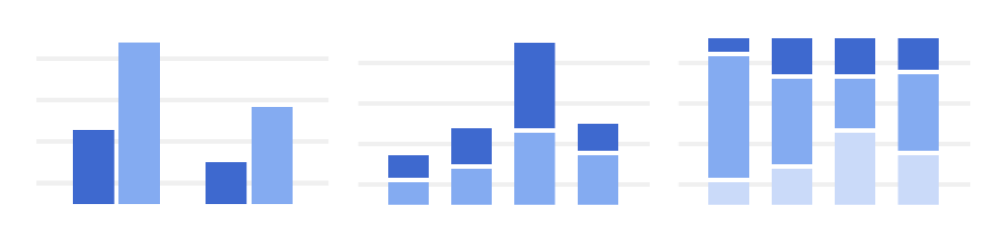

* **Line**: a line chart showcases trends in your data over a period of time. The last line chart example is a combo chart which can include a line chart. Refer to the description for the combo chart type.



* **Pie**: a pie chart is an easy way to visualize what proportion of the whole each data point represents.



* **Horizontal bar**: a bar chart functions similarly to a column chart, but is flipped horizontally.



* **Area**: area charts allow you to track changes in value across multiple categories of data.

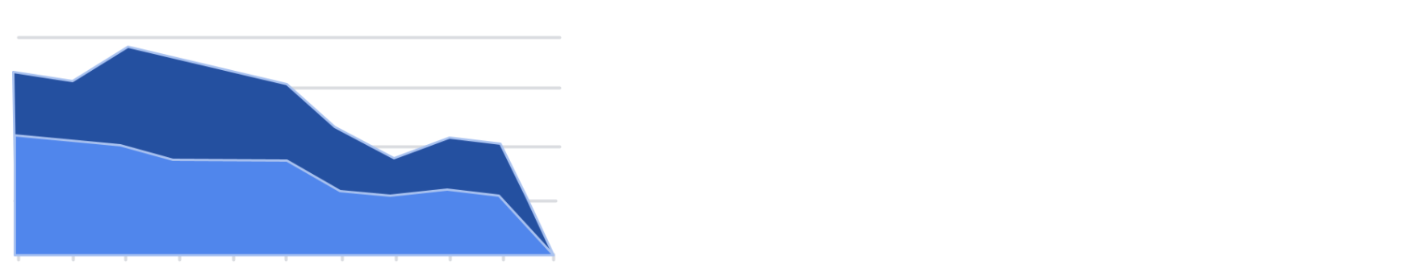

* **Scatter**: scatterplots are typically used to display trends in numeric data.



* **Combo**: combo charts use multiple visual markers like columns and lines to showcase different aspects of the data in one visualization. The example below is a combo chart that has a column and line chart together.



You can find more information about other charts here:

* [Types of charts and graphs in Google Sheets:](https://support.google.com/docs/answer/190718?hl=en) a Google Help Center page with a list of chart examples you can download.
* [Excel Charts](https://www.tutorialspoint.com/excel_charts/excel_charts_types.htm): a tutorial outlining all of the different chart types in Excel, including some subcategories.

## **How visualizations differ in Tableau**

As you have also learned, Tableau is an analytics platform that helps data analysts display and understand data. Most if not all of the charts that you can create in spreadsheets are available in Tableau. But, Tableau offers some distinct charts that aren’t available in spreadsheets. These are handy guides to help you select chart types in Tableau:

* [Which chart or graph is right for you?](http://www.tableau.com/sites/default/files/media/which_chart_v6_final_0.pdf) This presentation covers 13 of the most popular charts in Tableau.
* [The Ultimate Cheat Sheet on Tableau Charts](https://towardsdatascience.com/the-ultimate-cheat-sheet-on-tableau-charts-642bca94dde5). This blog describes 24 chart variations in Tableau and guidelines for use.

## **Types of visualizations in Tableau**

In addition to more traditional charts, Tableau also offers some more specific visualizations that you can use in your dashboard design:

* **Highlight tables** appear like tables with conditional formatting. Review the [steps to build a highlight table](https://help.tableau.com/current/pro/desktop/en-us/buildexamples_highlight.htm).
* **Heat maps** show intensity or concentrations in the data. Review the [steps to build a heat map](https://help.tableau.com/current/pro/desktop/en-us/buildexamples_highlight.htm).
* **Density maps** illustrate concentrations (such as a population density map). Refer to [instructions to create a heat map for density](https://help.tableau.com/current/pro/desktop/en-us/maps_howto_heatmap.htm).
* **Gantt charts** demonstrate the duration of events or activities on a timeline. Review the [steps to build a Gantt chart](https://help.tableau.com/current/pro/desktop/en-us/buildexamples_gantt.htm).
* **Symbol maps** display a mark over a given longitude and latitude. Learn more from this [example of a symbol map](https://interworks.com/blog/ccapitula/2014/08/18/tableau-essentials-chart-types-symbol-map/).
* **Filled maps** are maps with areas colored based on a measurement or dimension. Explore an [example of a filled map](https://interworks.com/blog/ccapitula/2014/09/23/tableau-essentials-chart-types-filled-map/).
* **Circle views** show comparative strength in data. Learn more from this [example of a circle view](https://interworks.com/blog/ccapitula/2014/10/17/tableau-essentials-chart-types-circle-view/).
* **Box plots**, also known as **box and whisker charts,** illustrate the distribution of values along a chart axis. Refer to the [steps to build a box plot](https://help.tableau.com/current/pro/desktop/en-us/buildexamples_boxplot.htm).
* **Bullet graphs** compare a primary measure with another and can be used instead of dial gauge charts. Review the [steps to build a bullet graph](https://help.tableau.com/current/pro/desktop/en-us/qs_bullet_graphs.htm).
* **Packed bubble charts** display data in clustered circles. Review the [steps to build a packed bubble chart](https://help.tableau.com/current/pro/desktop/en-us/buildexamples_bubbles.htm).

## **Key takeaway**

This reading described the chart types you can create in spreadsheets and introduced visualizations that are more unique to Tableau.

[CREATE A DATA VISUALIZATION IN TABLEAU](https://www.coursera.org/learn/visualize-data/lecture/64k7B/create-a-data-visualization-in-tableau)

Hi and welcome back. In this video, we're going to use tableau to create a database, a great way to share insights with others.

To begin, you'll need to download the data set we'll use for this activity. Click the link[CO2-Dataset.xlsx](https://docs.google.com/spreadsheets/d/1Um8szXOWKl4nbgBsSkCegC1qgxdH-YXi/template/preview)to create a copy of the data set and download it. If you don't have a Google account, download the data set directly from the attachment. As we go through the steps, you can put this video on one side of the screen and follow along in another window. You might notice your screen is slightly different from what you see here. Tableau might have updated its interface, but the steps should be pretty much the same. First, log in to Tableau Public. If you haven't created an account, go back to the reading about logging into Tableau Public. Okay, now go to the circle and select My Profile. From there, choose Create a Viz. This will open the Tableau Public interface.

From the Connect to Data window, go to the Files tab and upload the CO2 data set we downloaded earlier. Or you can navigate to the Data tab to the Tableau Public interface. Under the drop down, click new Data source, then open the CO2 data set. After the data uploads, the screen will show the data source interface. Underneath connections, double-click on the sheet CO2 data cleaned to load that data into the main part of the screen. You can also drag and drop the sheet into the area where it says Drag tables here. Click Update now to preview the data you opened in the bottom portion of the screen. Each row corresponds to a single data point, and each column represents a different feature. Tableau interprets the type of data in each column. Each icon represents a different type of data. For example, a number sign represents numerical data, while an abc represents string data. A globe represents geographic data, and so on. Tableau has interpreted the first two columns as geographic data, the third column as string data, and the last three columns as numeric data. All right, let's make a data viz that demonstrates the amount of CO2 emissions that come from each country. To do this, choose the Sheet 1 tab, on the far left of the screen is a banner with column names above a gray line. In tableau, these are called the dimensions of the data. Below this line, are the different measures that you can track for these dimensions.

To create a chart that displays the CO2 emissions per country, we're going to start by double-clicking the country name dimension. The main display will show a map of the countries on the planet, with dots indicating which countries are represented in the data.

The dots are all the same size because with no measure selected, tableau defaults to scale each country equally.

If you want to scale by CO2 emissions, we'll need to include a specific measure. Double-click or drag and drop onto the sheet the measure CO2 kilotons. This will change the size of the dots to be proportional to the amount of CO2 emitted.

Tableau has a wide selection of options for depicting the measures for a given dimension. Most of these options are contained in the middle column between the main display and the columns with dimensions and measures. Now, let's customize the look of our chart to better communicate trends in the data. If we drag and drop a measure on one of the marks, such as color, size, and label, we can change that aspect of the measure's visualization on the chart. For instance, say we want to change the color of the CO2 measure, we would drag the measure CO2 kilotons to the box with the color label. Then we can select this box to pull up a list of color options. Feel free to pause this video and play around with the different options, get creative. If you ever want to reverse a change that you make to a tableau sheet, just use the back arrow. There it is, we just created our first chart using Tableau. But what if we wanted to change the dimensions or measures? Instead of visualizing the CO2 per country, maybe we want to chart the CO2 per capita per region. To do this, we could double-click on the dimension Region and then do the same for the measure CO2 Per Capita. This builds a new chart. We can edit the title by hovering the cursor over the title box and clicking on the arrow to bring up a drop down menu. Then we'll choose the Edit Title. Let's give it the name Global CO2 Emissions. Or if we wanted to delete a chart, we could select the Clear Sheet button in the toolbar. This will wipe out the chart and bring us back to an empty sheet. Don't worry if you do this by accident or change your mind. The back button introduced earlier will bring the chart back. To delete a sheet entirely, right-click on the sheets tab and select Delete. We won't be able to delete a sheet if it's the only sheet in our file. But be careful, unlike clearing a sheet, deleting a sheet altogether cannot be undone.

Make sure to save your progress by hovering over the file tab and selecting Publish As. Congratulations, now you're ready to start visualizing your data. This is far from the end of the story, though. Soon you will explore more advanced tools in tableau.

[HANDS-ON ACTIVITY: CREATE A DATA VISUALIZATION IN TABLEAU](https://www.coursera.org/learn/visualize-data/quiz/AlTiN/hands-on-activity-create-a-data-visualization-in-tableau)



## **Activity Overview**



Now that you know how to create a visualization in Tableau, you’ll use the dataset and instructions in this activity to create your own visualization. If you have questions along the way, refer to the previous video, [Create a data visualization in Tableau](https://www.coursera.org/learn/visualize-data/lecture/64k7B/create-a-data-visualization-in-tableau).

In this activity, you’ll practice the following skills:

* Connect data to Tableau.
* Create a chart.
* Customize your chart.
* Delete a chart or sheet.

By the time you complete this activity, you’ll be able to create and customize visualizations in Tableau. This will enable you to share your valuable data insights with others.



### Step-By-Step Instructions

Follow the instructions to complete each step of the activity. Then answer the question at the end of the activity before going to the next course item.

### Step 1: Access the dataset

Click the following link and select Use Template to create a copy of the dataset. Download this dataset to your computer by selecting File > Download > Microsoft Excel (.xslx). If you don’t have a Google account, download the dataset directly from the attachment below.

Link to dataset: [CO2](https://docs.google.com/spreadsheets/d/1LwGHDgJkXSm8b0ziSDyC8pQGqjYVGpX9mAEVPs2KQgY/copy)

OR

Download dataset:

[CO2 Dataset](https://d3c33hcgiwev3.cloudfront.net/zhTyc2uLRjKsu73XdR0nQg_9f719016a1ca48ec8a728e28ab6fecf1_CO2-Dataset.xlsx?Expires=1715299200&Signature=isQbt0~4oLxg9ZRDXVb1fmQR5CaCCP8T84pwlx-Oy0Docxg6nXpREUTS~keilZFSxDoRq9JiSVIYDLS04HCiTneZhE62RTr6ZFWMYGLzR7X1VRUJuTc0lVzA7wIcOK9wYUOqRVdUwdo4R8K3p3M1kZT13JLauqcBi81IBKIGdGI_&Key-Pair-Id=APKAJLTNE6QMUY6HBC5A)

[XLSX File](https://d3c33hcgiwev3.cloudfront.net/zhTyc2uLRjKsu73XdR0nQg_9f719016a1ca48ec8a728e28ab6fecf1_CO2-Dataset.xlsx?Expires=1715299200&Signature=isQbt0~4oLxg9ZRDXVb1fmQR5CaCCP8T84pwlx-Oy0Docxg6nXpREUTS~keilZFSxDoRq9JiSVIYDLS04HCiTneZhE62RTr6ZFWMYGLzR7X1VRUJuTc0lVzA7wIcOK9wYUOqRVdUwdo4R8K3p3M1kZT13JLauqcBi81IBKIGdGI_&Key-Pair-Id=APKAJLTNE6QMUY6HBC5A)

[](https://d3c33hcgiwev3.cloudfront.net/zhTyc2uLRjKsu73XdR0nQg_9f719016a1ca48ec8a728e28ab6fecf1_CO2-Dataset.xlsx?Expires=1715299200&Signature=isQbt0~4oLxg9ZRDXVb1fmQR5CaCCP8T84pwlx-Oy0Docxg6nXpREUTS~keilZFSxDoRq9JiSVIYDLS04HCiTneZhE62RTr6ZFWMYGLzR7X1VRUJuTc0lVzA7wIcOK9wYUOqRVdUwdo4R8K3p3M1kZT13JLauqcBi81IBKIGdGI_&Key-Pair-Id=APKAJLTNE6QMUY6HBC5A)

### Step 2: Connect data to Tableau

1. Log in to Tableau Public. If you have not yet created an account, refer to the reading [Begin to use Tableau Public](https://www.coursera.org/learn/visualize-data/supplement/HyqLQ/logging-into-tableau-public).

Note: Tableau frequently updates its user interface. The latest changes may not be reflected in the screenshots presented in this activity, but the principles remain the same. Adapting to changes in software updates is an essential skill for data analysts, and it’s helpful for you to practice troubleshooting. You can also reach out to your community of learners on the discussion forum for help.

2. Select the user profile icon and choose My Profile to display your Tableau profile and any vizzes you’ve created.

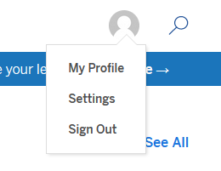

3. Select the Create a Viz button.

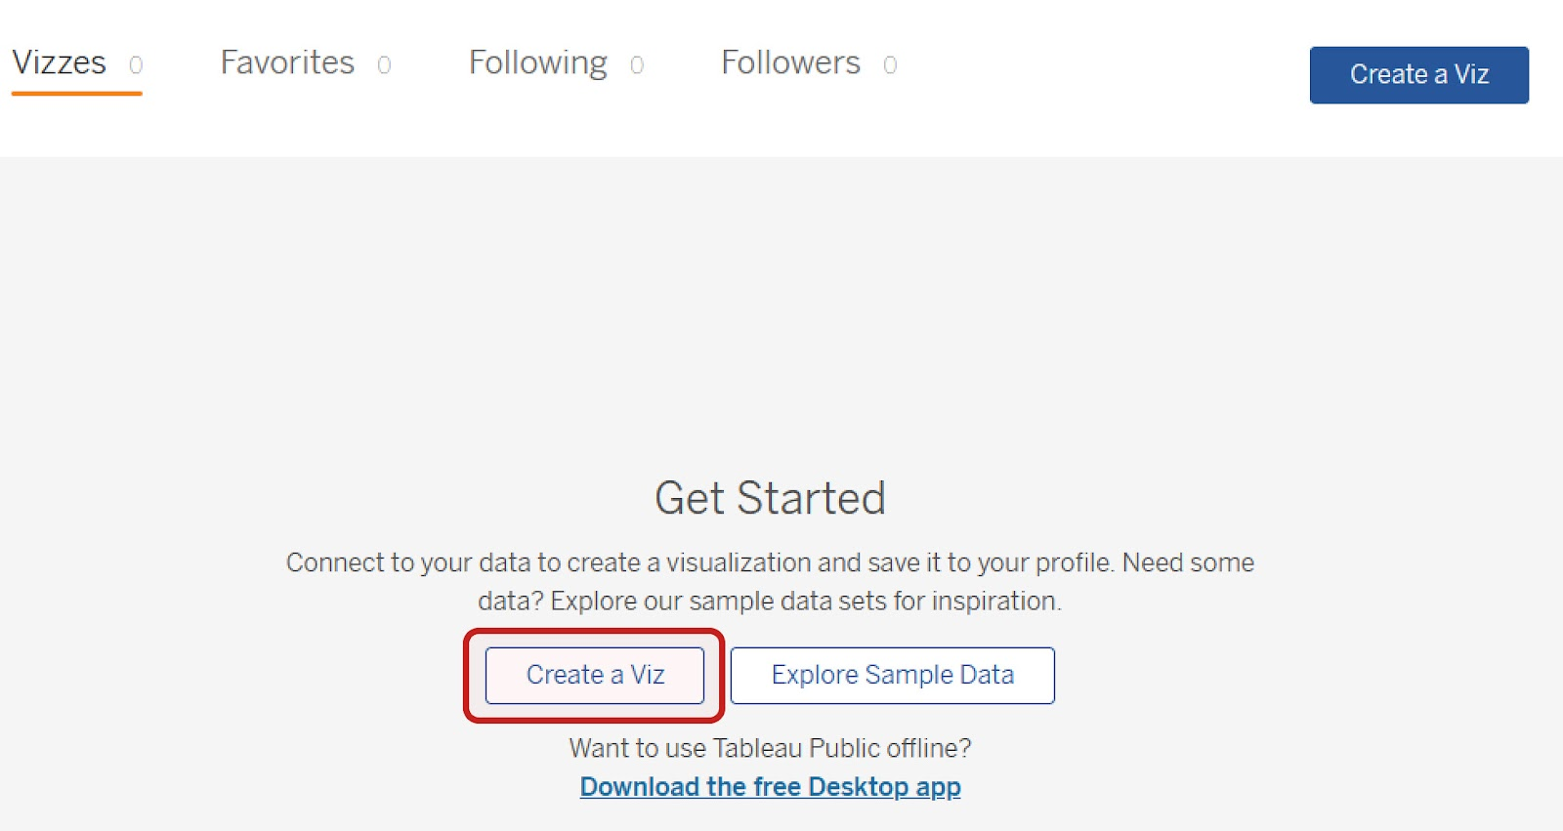

4. When you select Create a Viz, Tableau may open the Connect to Data dialog box. If so, select the Files tab and upload the CO2 dataset you downloaded earlier.

If selecting Create a Viz does not open the Connect to Data dialog box, in the Tableau Public interface, select the Data tab and then New Data Source. Upload the CO2 dataset.

5. After you upload the data, notice the list of data connections and sheets beside the main Data-Source Interface. The data connection is the CO2 dataset you’ve connected. It contains eight sheets, including one labeled CO2 Data Cleaned.

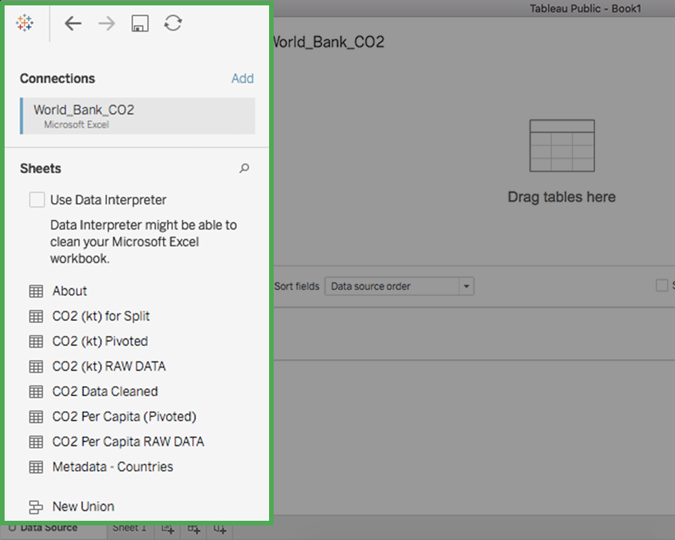

6. Double-click on the sheet CO2 Data Cleaned to load that sheet's data into the main part (canvas) of the Tableau Public page. Alternatively, drag and drop the sheet onto the canvas where it says Drag tables here.

Note: Loading a sheet twice may cause you to inadvertently create a table relationship between the loaded sheets (similar to joining tables in SQL). You’ll explore this later in the course. For now, if you do this accidentally, don’t worry! Just right-click on the second box to remove it from the table listings.

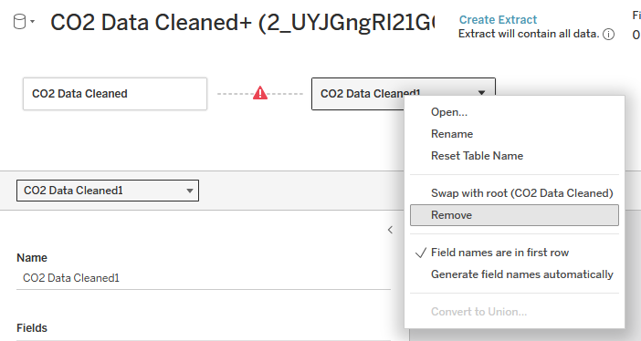

A dotted line with a warning symbol connects the two. The down arrow in the right of CO2 data cleaned 1 field has been selected, which opens a menu with the following choices: Open, Rename, Reset Table Name, Swap with root (CO2 Data Cleaned), Remove, Field names are in first row, Generate field names automatically. The Remove option is highlighted.

7. When the sheet is loaded, Tableau displays the table schema with the field names, data types, etc. Select the Update Now button to bring up the first 100 rows in the table; you can increase the number of rows in the settings above the data view. In the following image, the number of rows displayed has been increased to 1,000.

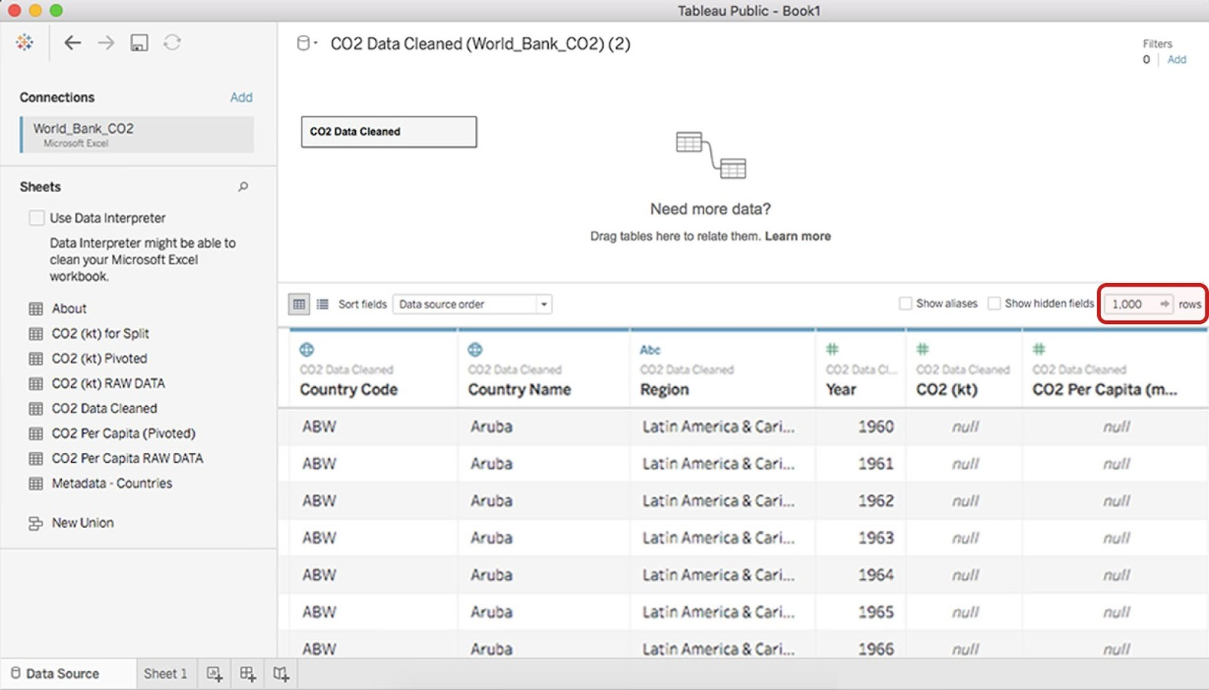

Each row corresponds to a single data point, and each column represents a different feature.

Tableau automatically interprets the type of data in each column and displays the following icons above the column names, to indicate how Tableau has interpreted the data in the column:

* #: Numeric data
* Abc: String data
* Globe: Geographic data
* Calendar: Date data
* Calendar: Date and time data

In the previous image, Tableau has interpreted the first two columns as geographic data, the third column as string data, and the last three columns as numeric data.

### Step 3: Access your data in Tableau

Now that you have all of your data loaded into Tableau, you can use it to create a visualization in which the CO2 emissions are displayed per country.

Select the Sheet 1 tab to open the New workbook pane in the display.

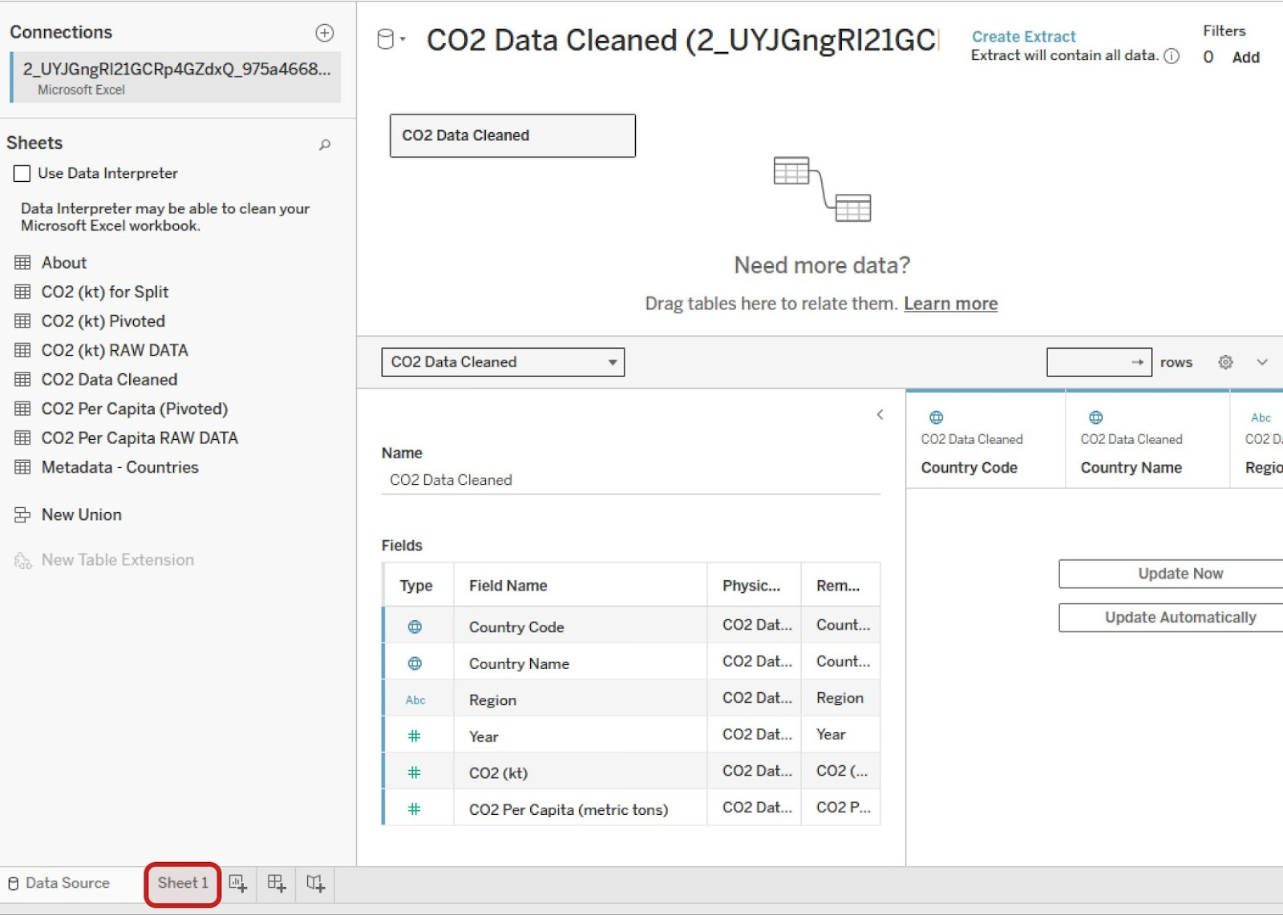

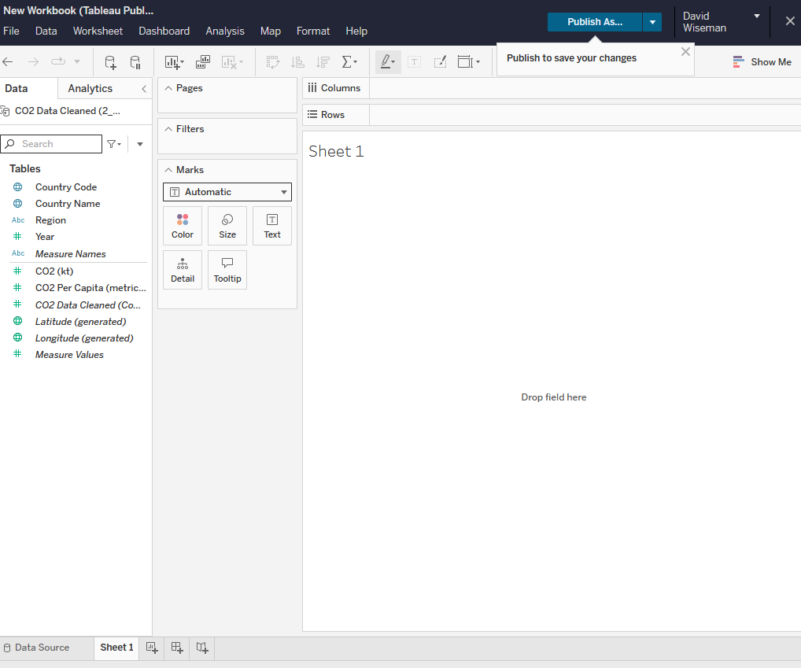

### Step 4: Understand dimensions and measures

The Data pane in the side bar displays column names in a list. In Tableau and most business intelligence software, you will find two types of data elements: dimensions and measures. According to the [Tableau documentation](https://help.tableau.com/current/pro/desktop/en-us/datafields_typesandroles.htm):

* Dimensions contain qualitative values (such as names, dates, or geographical data). You can use dimensions to categorize, segment, and reveal the details in your data. Dimensions affect the level of detail in the view.
* Measures contain numeric, quantitative values that you can measure. Measures can be aggregated. When you drag a measure into the view, Tableau applies an aggregation to that measure (by default).

In the Data pane of the Tableau side bar, you’ll see dimensions listed above the gray line and measures below the gray line (under Measure Names). These allow you to build and customize charts.

### Step 5: Create a visualization chart of CO2 emissions

Now, create a chart that displays the CO2 emissions per country. In the Data pane of the sidebar, double-click the Country Name dimension. The canvas displays a map of the countries with points indicating which countries are represented in the data.

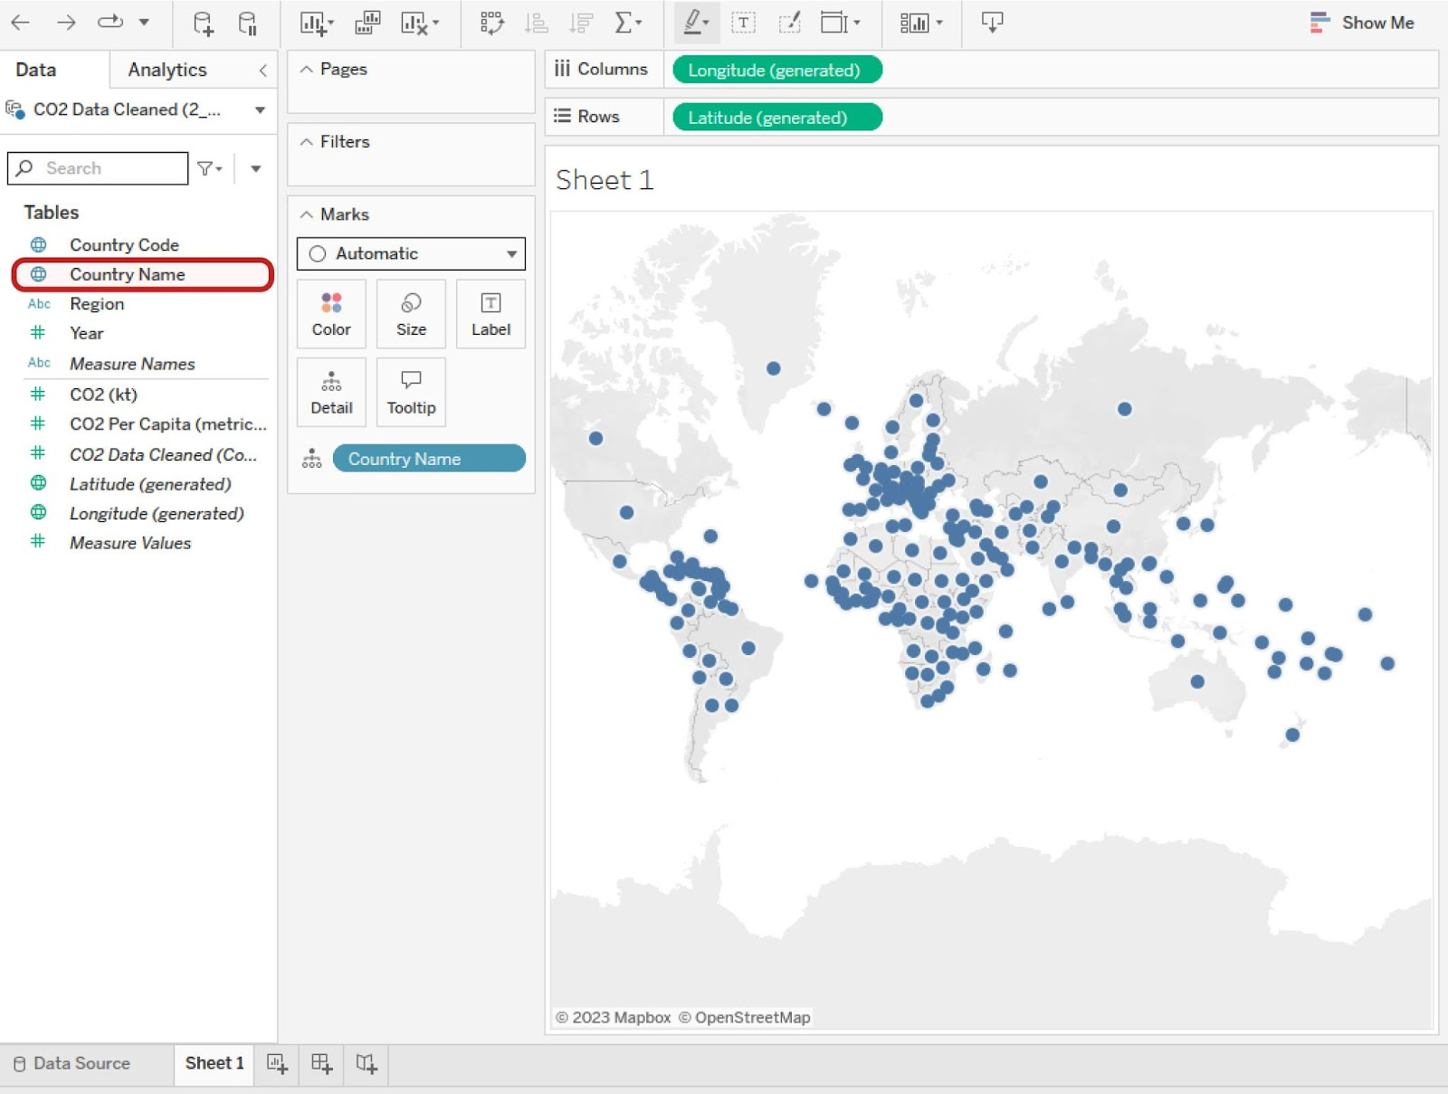

The points are all the same size because, if there is no measure selected, Tableau defaults to scale each country equally. If you want to scale point size by kilotons (kt) of CO2 emissions, you need to include a specific measure.

To do this, double-click (or drag and drop onto the sheet) the measure CO2 (kt) in the Data pane. This changes the size of the dots to be proportional to the amount of CO2 emitted, as in the example below.

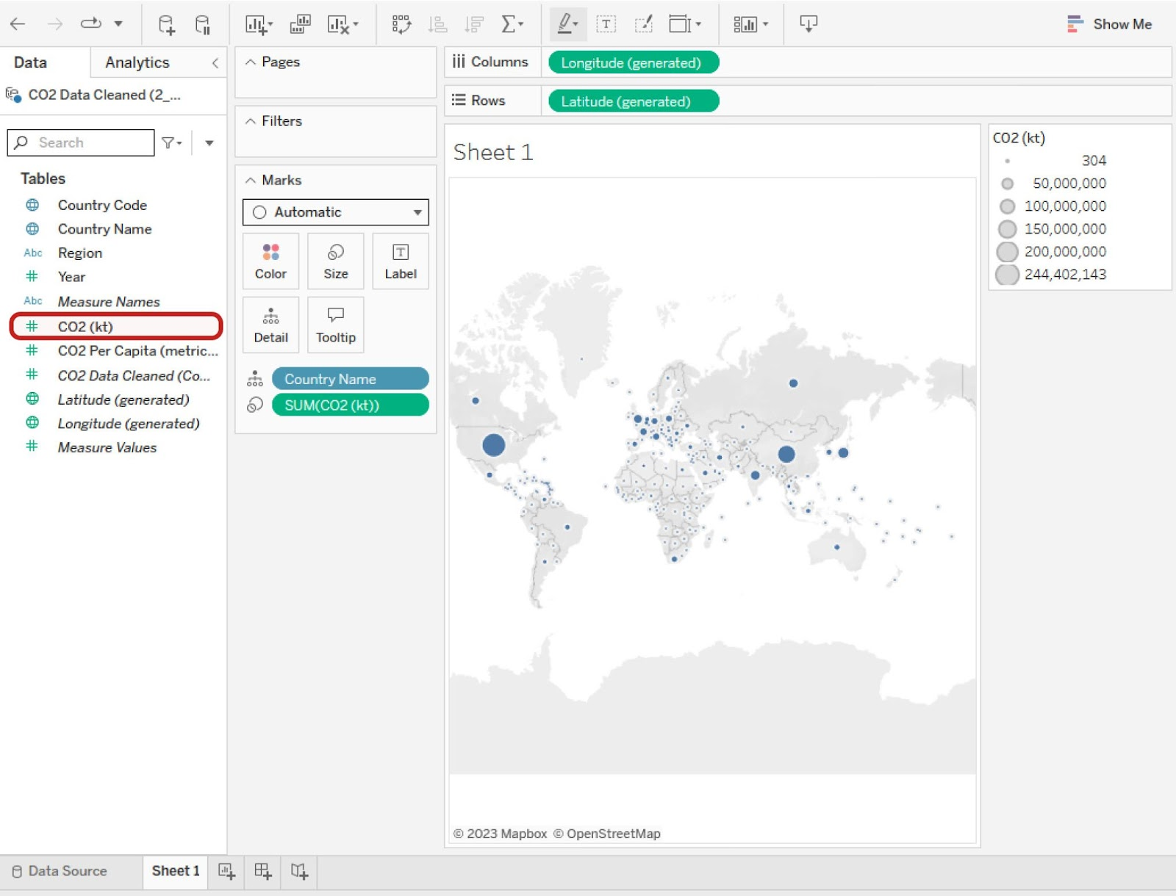

There is a callout box around CO2 (kt). The world map now displays a dot marker on each country, but the point vary in size based on each country’s CO2 emissions.

Tableau has a wide selection of options for depicting the measure of a given dimension. Most of these options are contained in the Marks card, Filter shelf, and Page shelf.

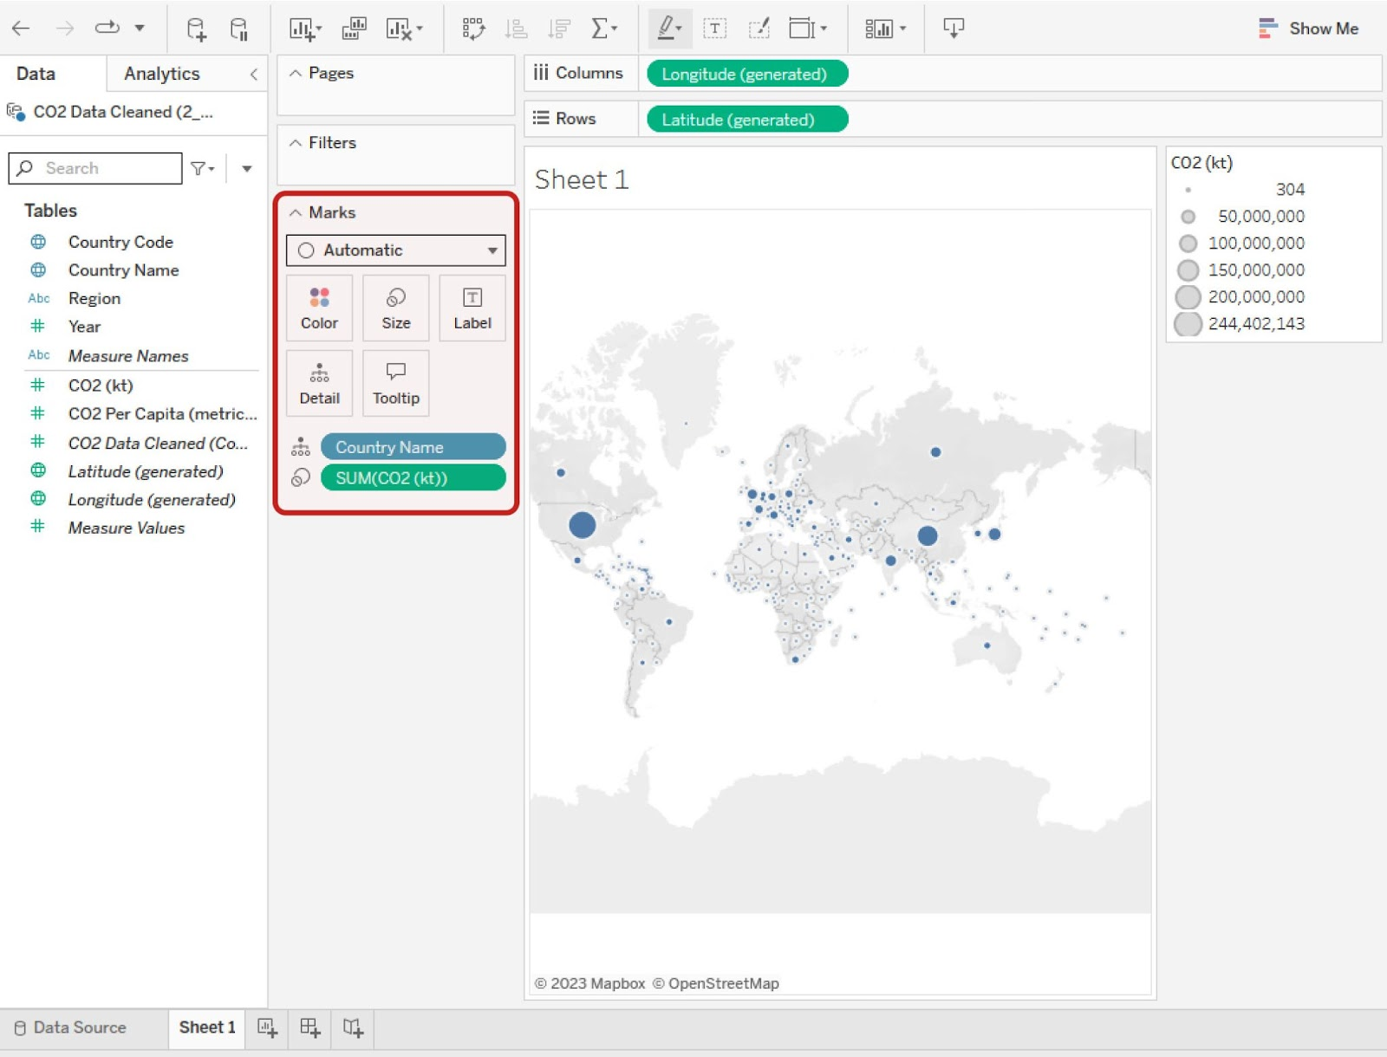

### Step 6: Customize your chart's dimensions and measures

If you drag and drop a measure on one of the option classes, such as Color, Size, or Label, you can change that aspect of the measure’s visualization on the chart.

For example, if you want to change the color of the CO2 measure, drag the measure CO2 (kt) from the sidebar to the Marks card and drop it on the Color box. This will change the measure’s configuration to a color breakdown. Then, select the Color box in the Marks card to pull up a menu for changing the color and its options. To change the color, select the Edit Colors button.

Try out the different options available. You can always reverse a change by selecting the Back arrow button in the toolbar or using your computer's default undo keyboard shortcut. Similarly, you can redo changes you make by selecting the Forward arrow button.

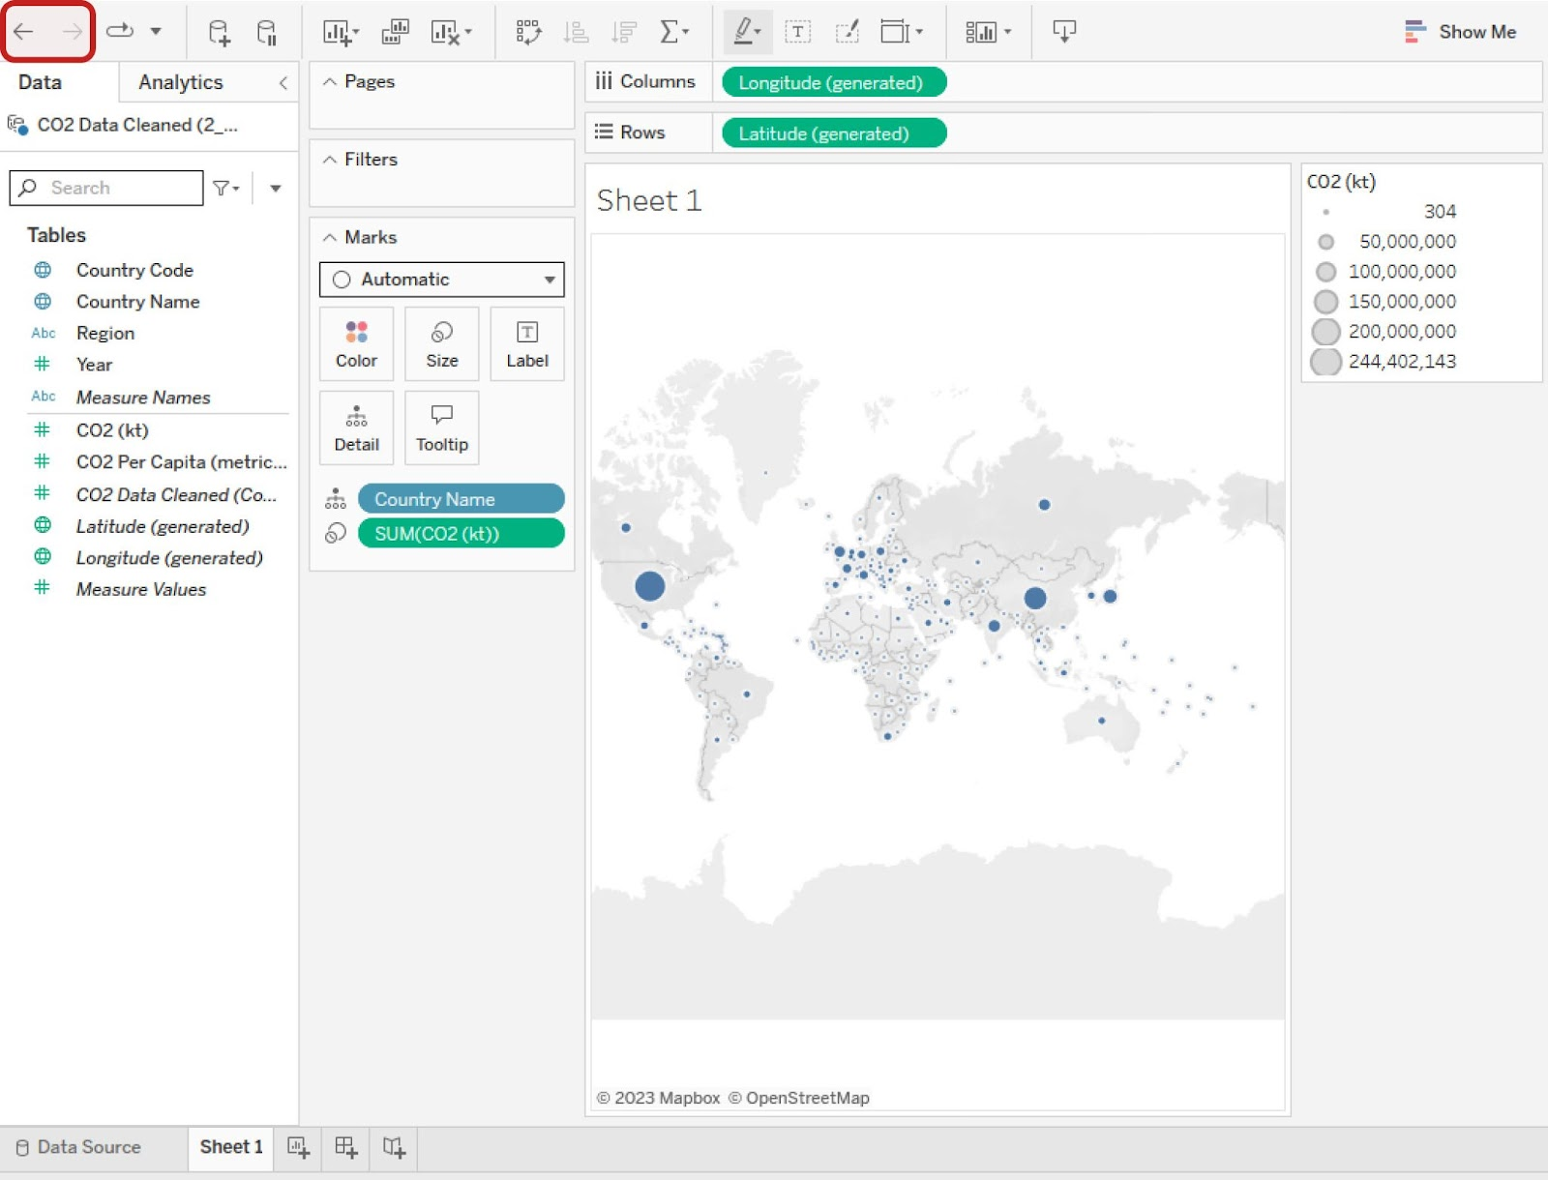

### **Change dimensions and measures**



Changing either the dimension or the measure on a chart is simple. Suppose that, instead of visualizing the CO2 per country, you want to chart the CO2 per capita per region. To do this, in the sidebar, double-click on the dimension Region. Then double-click on the measure CO2 Per Capita. This will result in seven world charts: East Asia & Pacific, Europe & Central Asia, Latin America & Caribbean, Middle East & North Africa, North America, South Asia, and Sub-Saharan Africa.

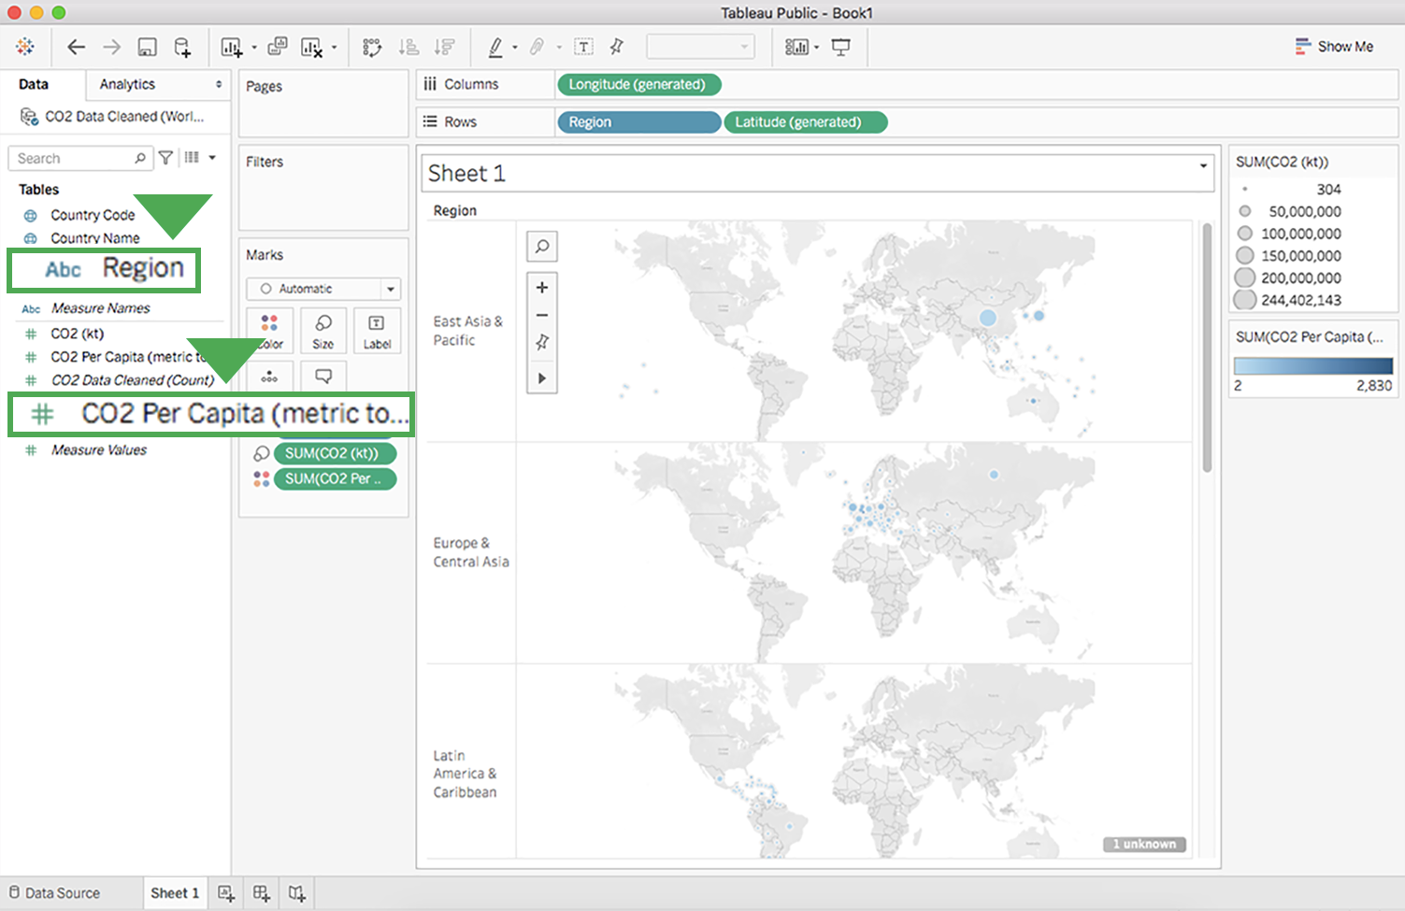

Just below this, under measure names, there is a callout box around CO2 per capita in metric tons.

### Step 7: Customize your chart's title

Currently, the title of this chart is Sheet 1. To give the chart a more descriptive title:

1. Point to the title box, select the dropdown list menu, and then select Edit Title to open the Edit Title dialog box. (You can also double-click Sheet 1 to open the Edit Title dialog box where you can change the title.)

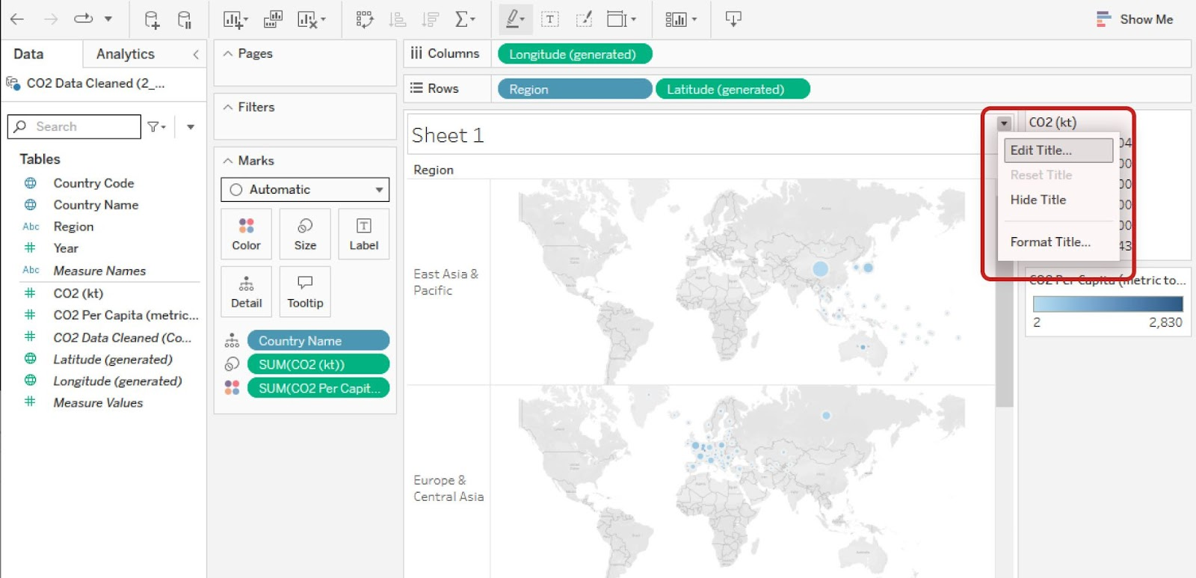

The menu includes options to Edit Title, Reset Title, Hide Title, and Format Title. Edit Title is highlighted.

2. Enter any title you wish and select OK. A descriptive title helps people understand what the chart visual seeks to convey. For example, you could title this chart “CO2 Per Capita by Region.”

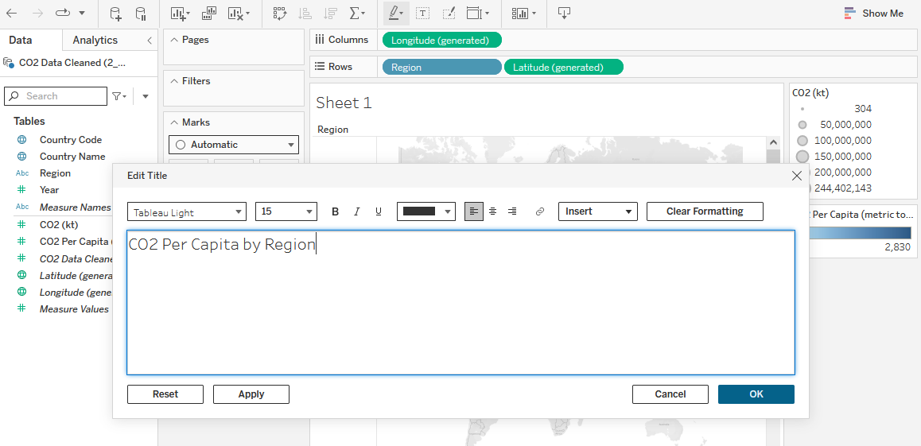

You can also choose to insert an object, or clear formatting. CO2 Per Capita by Region has been typed into the title field. Below four buttons allow you to Reset, Apply, Cancel, or OK

### Step 8: Delete a chart or sheet

### **Delete a chart**

To delete a chart from the sheet, select the Clear Sheet button in the toolbar.

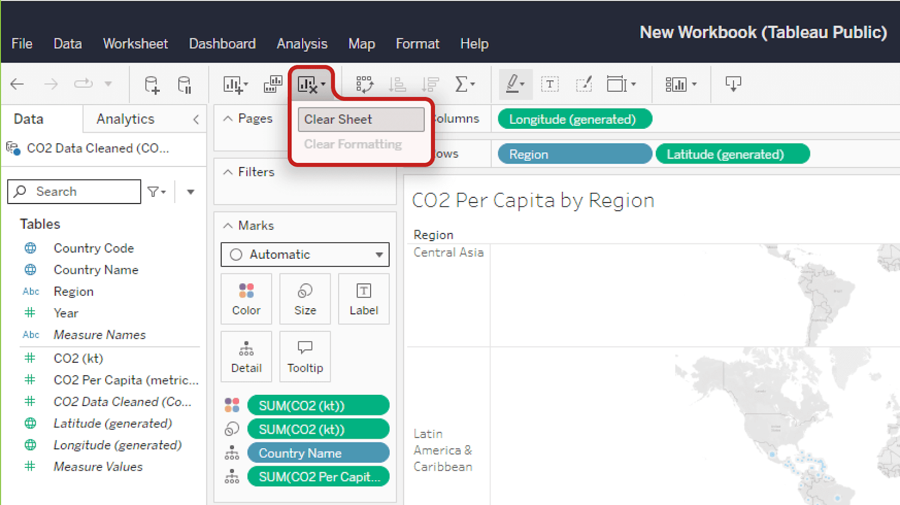

On this same dropdown menu, the clear formatting option is greyed out.]

This will completely delete the chart and bring you back to an empty sheet.

Note: This will not remove the sheet title.

If you delete a chart by accident or change your mind, select the Back button to undo the deletion.

### **Delete a sheet**

If you want to delete a sheet in its entirety, right-click on the sheet's tab at the bottom of the screen and select Delete. You won’t be able to delete a sheet if it is the only sheet in your file.

Note: Unlike clearing a sheet, deleting a sheet altogether cannot be reversed!

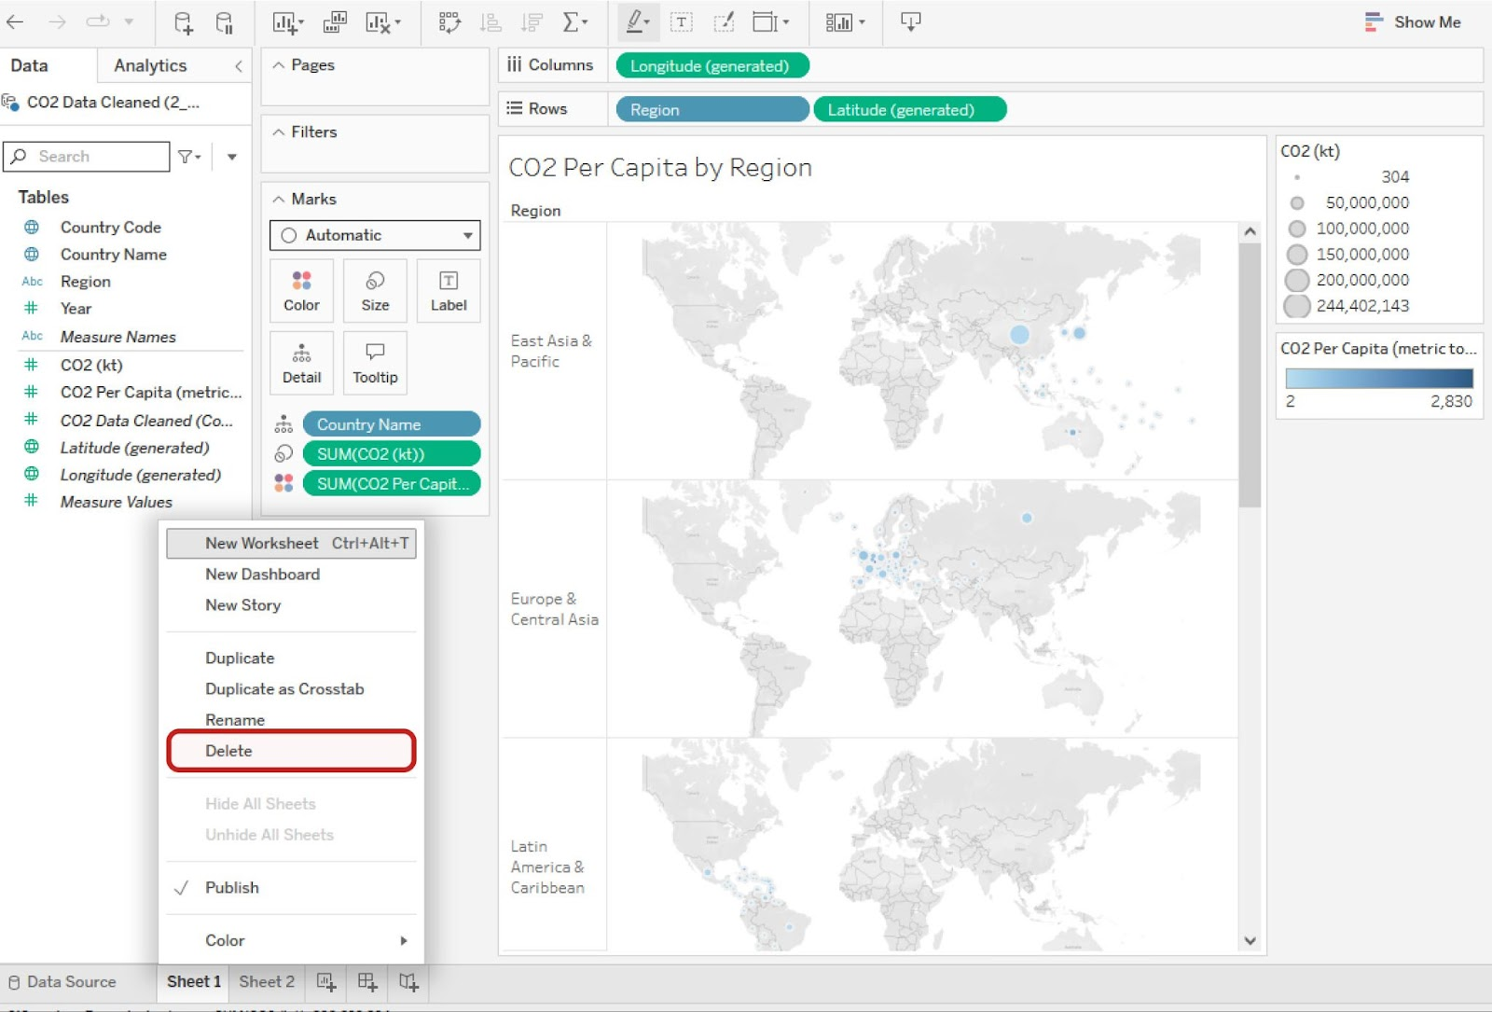

Menu choices include New Worksheet, New Dashboard, New Story, Duplicate, Duplicate as Crosstab, Rename, Delete, Hide All Sheets, Unhide All Sheets, Publish, and Color.

The skills you’ve practiced in this hands-on activity will help you get started visualizing your data. This is far from the end of the story, though. As you progress through this course, you’ll continue refining your Tableau skills.

[OPTIONAL: USING TABLEAU DESKTOP](https://www.coursera.org/learn/visualize-data/supplement/bMjvq/optional-using-tableau-desktop)

You have started exploring Tableau as a data visualization tool in business intelligence dashboards to convey insights with stakeholders. Throughout this program, you will continue to use and access Tableau—eventually using it to create your own dashboards. This reading will enable you to familiarize yourself with Tableau's interface and functionality.

## **Create a profile on Tableau Public**

With Tableau Public, you can create and share visualizations. If you don’t already have an account, make one on the [Tableau Public](https://public.tableau.com/s/) site. Note that trying to make an account from the main page will sign you up for a Tableau Free Trial rather than a Tableau Public account.

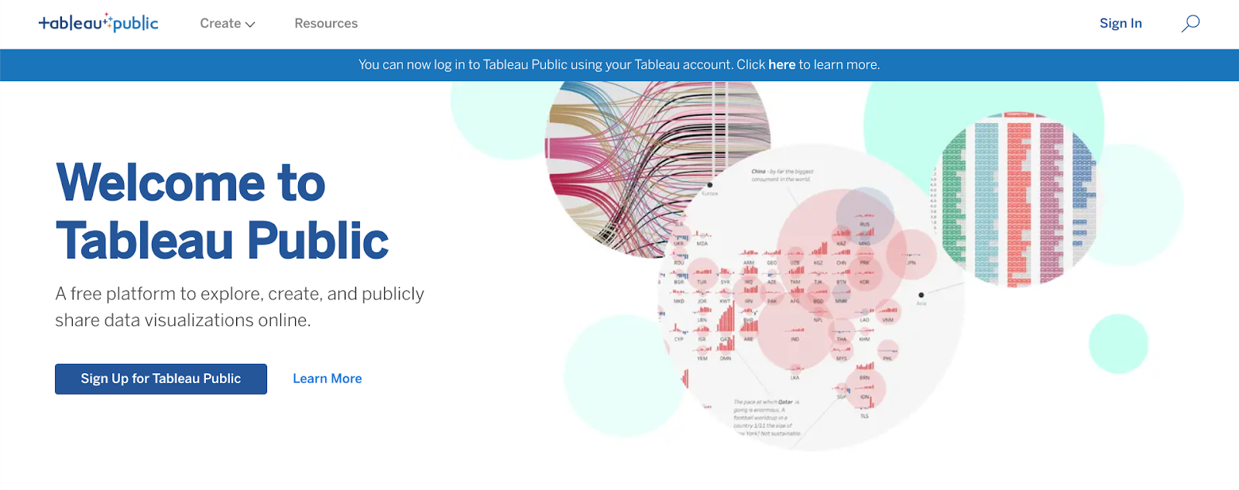

The difference between these two options is that a Free Trial lasts for 14 days, whereas Tableau Public gives you long-term access through the web version of the program. It has some limitations compared to the other versions of Tableau, but it is free to use and will enable you to complete the upcoming activities. You can also use your Tableau credentials to access Tableau Public if you already have an account! You are welcome to try the free trial or purchase Tableau, but it is not required for this program.

Complete the information in the signup form. When you click the **Create My Profile** button, you’ll be transferred to your profile page. This is where your Tableau Public visualizations can be made public to share with your peers. In the tabs on this page, you can access lists of visualizations you’ve made, visualizations you’ve favorited, authors you are following, and authors who are following you. By clicking **Edit Profile,** you can add additional information like your bio, title, organization, and links to social media accounts. This is also where you can enable Tableau Public’s **Hire Me** button. The **Hire Me** button will indicate to potential hiring managers that your Tableau skills are available for hire.

## **Optional: Download the desktop version**

With the desktop application, you can use features from Tableau Public without connecting to the internet. It is free to use, just like Tableau Public’s online version. Keep in mind that this application cannot be used on the Chromebook operating system and is not required for this course. If you are using Windows or Mac OS, this desktop application will enable you to complete upcoming activities that use Tableau Public. To download [Tableau Public Desktop Edition](https://www.tableau.com/products/public/download) (this is optional), log into your account and review the [system requirements](https://www.tableau.com/products/techspecs#public) for your operating system.

## **Loading and linking data**

Tableau enables you to load in your own data and link it to other datasets directly in the platform. When you log in, choose to **Create a Viz.** This will open a new worksheet where you can upload data or connect to online sources, such as your Google Drive.

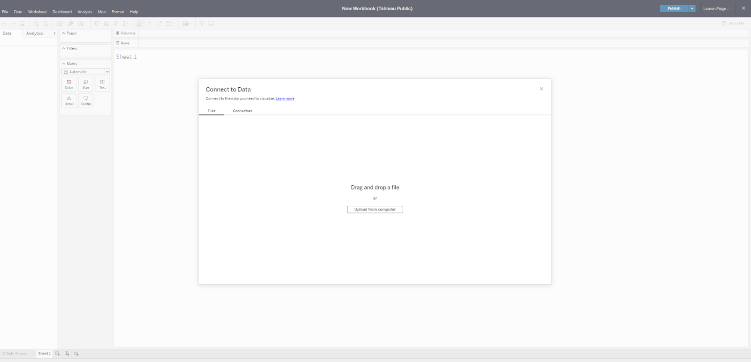

Once you upload data to your worksheet, it will populate the Connections pane.

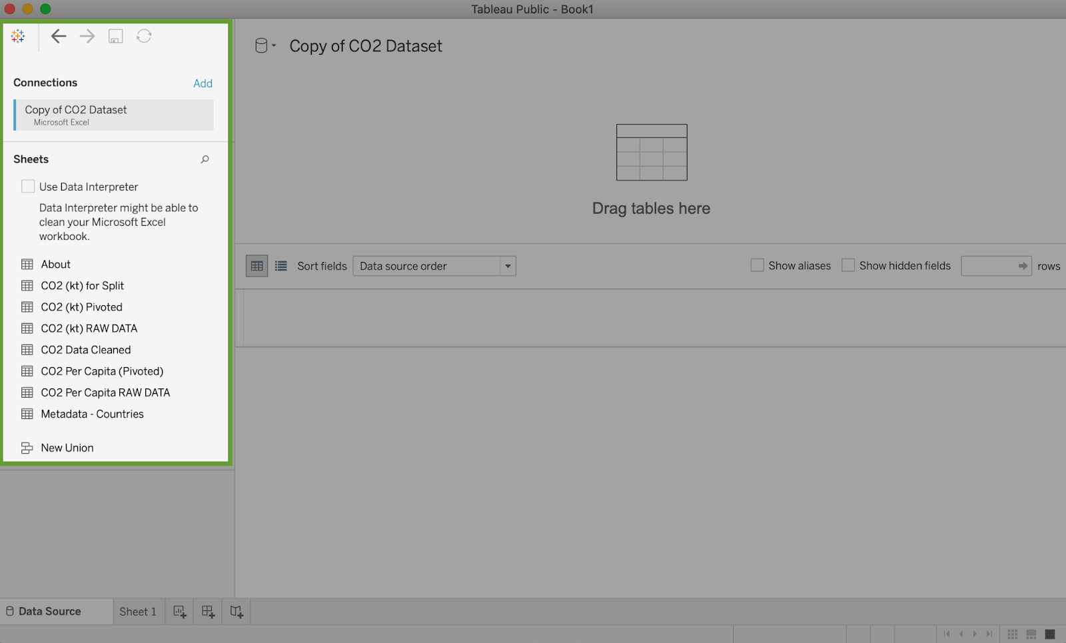

You can add more connections to other data sources in order to build visualizations that compare different datasets. Simply drag and drop tables from the Sheets section in order to join tables and generate those connections:

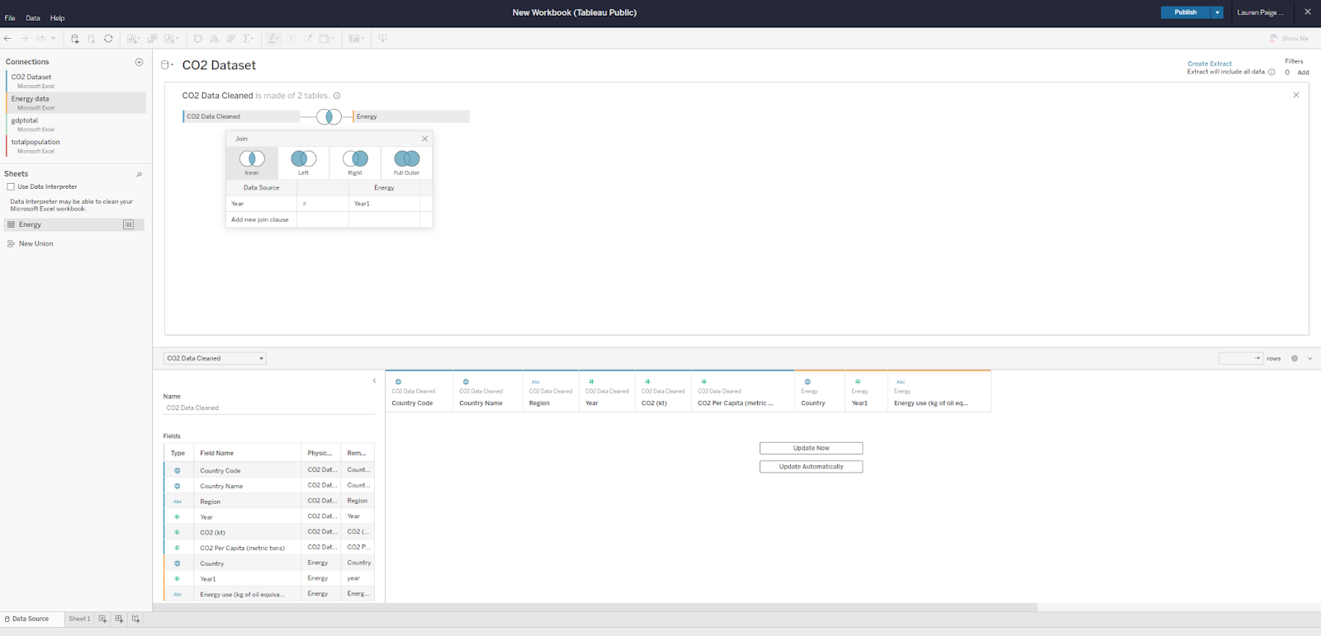

## **Dimensions and measures**

Tableau uses dimensions and measures to generate customized charts. For example, check out this chart focusing on CO2 emissions per country. The Country Name dimension can be used to show a map of the countries on the planet with dots indicating which countries are represented in the data.

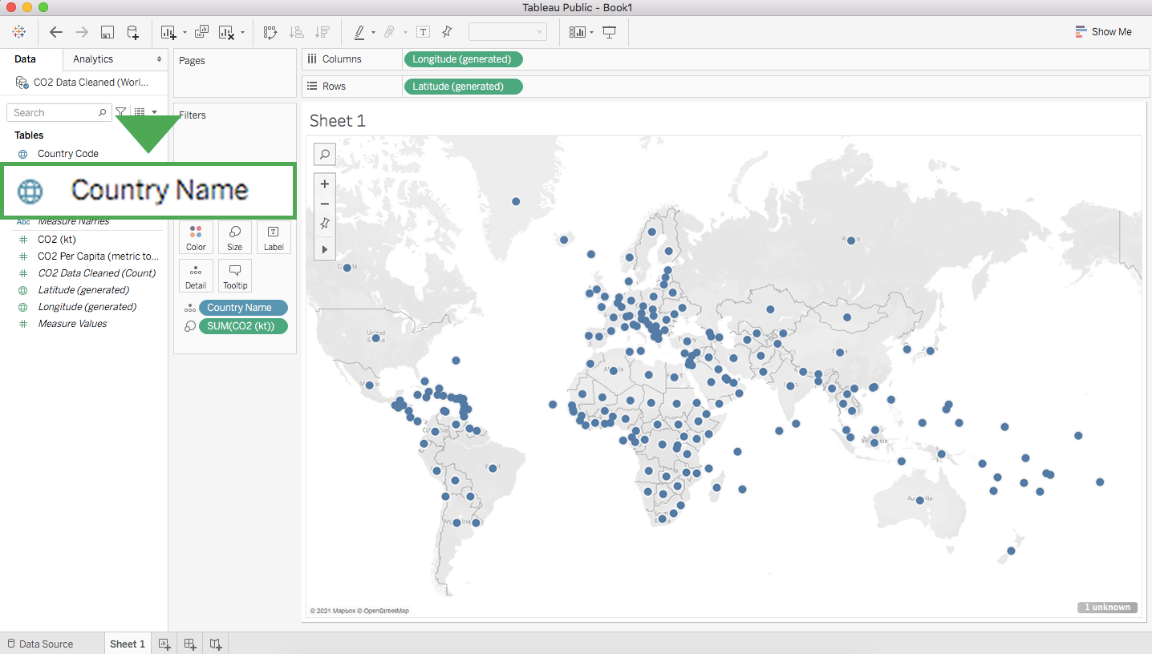

The dots are all the same size because—with no measure selected—Tableau defaults to scale each country equally. If you want to scale by CO2 emissions, you need to include a specific measure. Here is the same chart with a measure for CO2 kiloton (kt). This changes the size of the dots to be proportional to the amount of CO2 emitted:

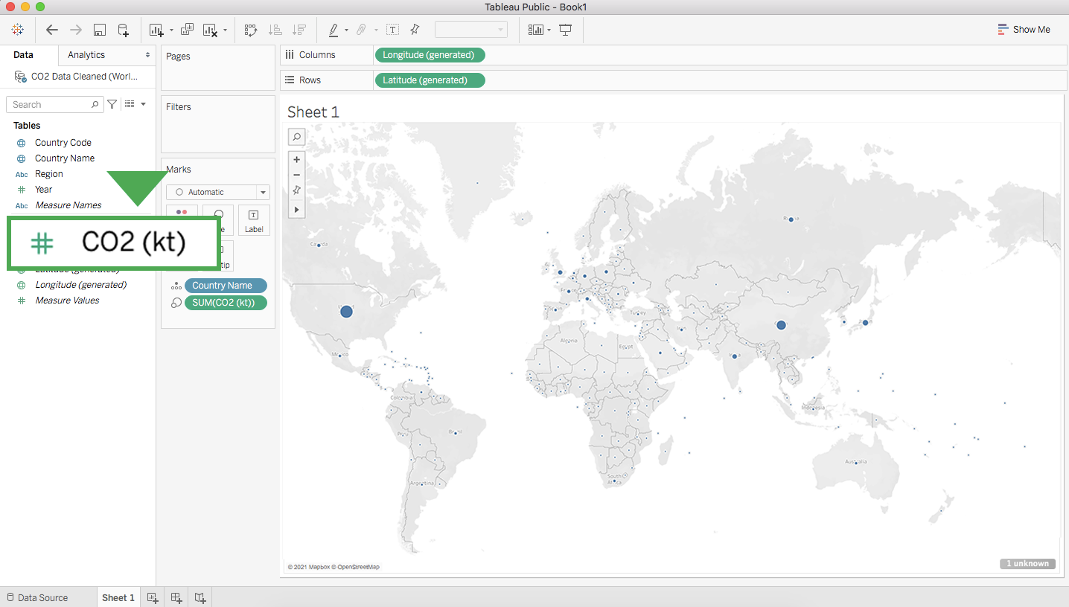

Tableau has a wide variety of options for depicting the measure for a given dimension. Most of these options are contained near the main display and the column with dimensions and measures.

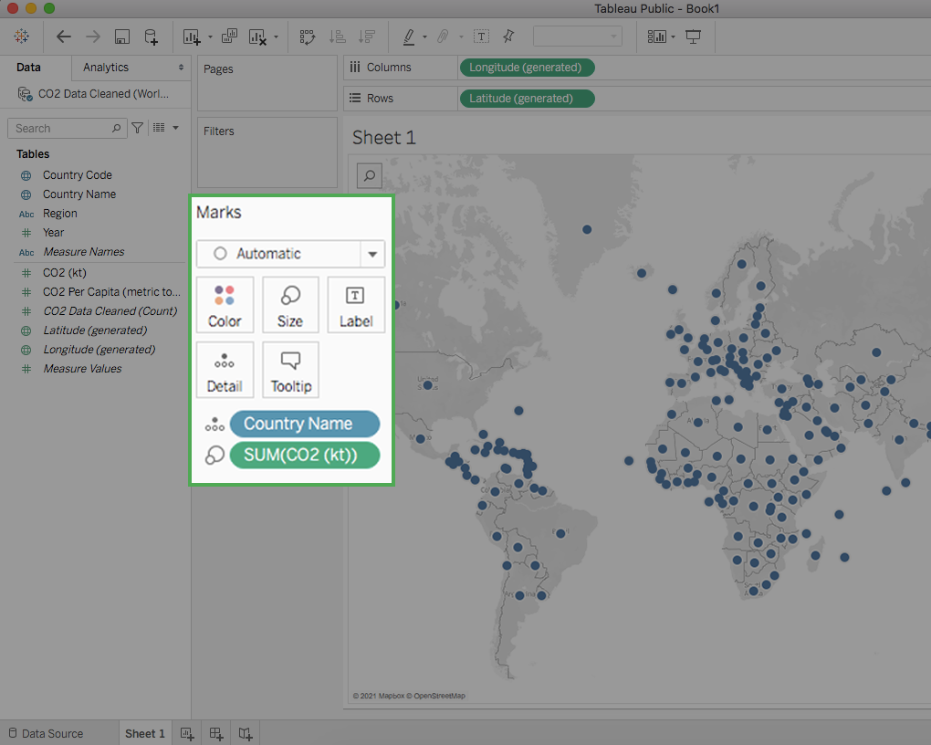

## **Key takeaways**

Tableau allows you to customize measures with options such as Color, Size, and Label, which change those aspects of the measure’s visualization on the chart. As you customize measures in Tableau, you will want to consider accessibility for your audience. As a refresher, you can check out [this video on accessible visualizations from the Google Data Analytics Certificate program.](https://www.coursera.org/learn/visualize-data/lecture/yVjKD/accessible-visualizations)

DESIGN VISUALIZATIONS IN TABLEAU

[OPTIMIZE THE COLOR PALETTE IN DATA VISUALIZATION](https://www.coursera.org/learn/visualize-data/lecture/zBZG7/optimize-the-color-palette-in-data-visualization)

[ESSENTIAL DESIGN PRINCIPLES](https://www.coursera.org/learn/visualize-data/supplement/n30Nd/essential-design-principles)

[MISLEADING VISUALIZATIONS](https://www.coursera.org/learn/visualize-data/discussionPrompt/4xtIo/misleading-visualizations)

[BONUS GUIDE: ADDITIONAL INSIGHTS ON SELECTING THE RIGHT DATA VISUALIZATION](https://www.coursera.org/learn/visualize-data/supplement/jQwMR/bonus-guide-additional-insights-on-selecting-the-right-data-visualization)

[SELF-REFLECTION: SELECT VISUALS AND CHARTS](https://www.coursera.org/learn/visualize-data/quiz/ud0AO/self-reflection-select-visuals-and-charts)

[GET CREATIVE](https://www.coursera.org/learn/visualize-data/lecture/Eytgs/get-creative)

[CREATING EFFECTIVE VISUALIZATIONS](https://www.coursera.org/learn/visualize-data/ungradedWidget/qCl2L/creating-effective-visualizations)

[TEST YOUR KNOWLEDGE ON CREATING VISUALIZATIONS IN TABLEAU](https://www.coursera.org/learn/visualize-data/quiz/E9xV8/test-your-knowledge-on-creating-visualizations-in-tableau)

OPTIONAL: WORK WITH MULTIPLE DATA SOURCES

[LINK MULTIPLE DATASETS IN TABLEAU](https://www.coursera.org/learn/visualize-data/lecture/C4Avg/link-multiple-datasets-in-tableau)

[HANDS-ON ACTIVITY: LINK MULTIPLE DATASETS IN TABLEAU](https://www.coursera.org/learn/visualize-data/quiz/ePEB4/hands-on-activity-link-multiple-datasets-in-tableau)

[TABLEAU RESOURCES FOR COMBINING MULTIPLE DATA SOURCES](https://www.coursera.org/learn/visualize-data/supplement/mx5BE/tableau-resources-for-combining-multiple-data-sources)

M2 CHALLENGE

[GLOSSARY TERMS FROM MODULE 2](https://www.coursera.org/learn/visualize-data/supplement/hd0z5/glossary-terms-from-module-2)